**Game Engine Optimisation – 13017861**

**Part 1: Chisel Changes**

Concave pen room into multiple convex map entities:

The concave pen rooms to multiple convex map entities has already been implemented as they allow rooms to have additional convex outcrops added onto them which increases the size and complexity of the rooms able to be created via this tool. The concave conversion takes any concave rooms, goes through them all and keeps splitting the rooms until they are all convex rooms.

Visportals:

To check the differences between the changes made in this assignment below I will include screenshots of the game running without any changes made.

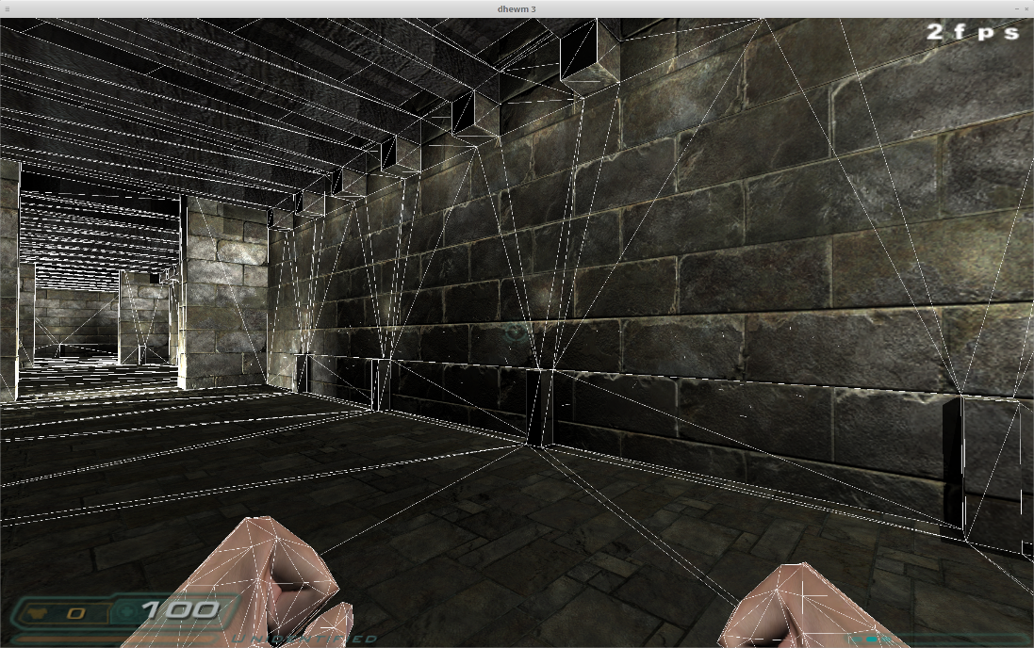

[Figure 1] The image above shows the game running in a custom map with no changes in the chisel code, the map created is a 6-room map with both horizontal and vertical doors and renders a total of 90 enemy units in rooms 4 and 5.

The objective in the creation of this map was to purely kill the framerate for testing purposes after changes are made. The console commands active for this screenshot are r_showTris 2 which is a command for the renderer which enables the viewing of the wireframe, the 2 classifier makes only the front facing wireframes viewable. The other command used here is com_showFPS 1, this command is a common command that shows the fps in the top right corner. As the screenshot shows the game with no optimisation runs at only 2fps due to the number of enemies rendered in the next rooms with the optimisations and changes the game should run at a higher fps. The next image is the same map with the command showTris upgraded to level 3.

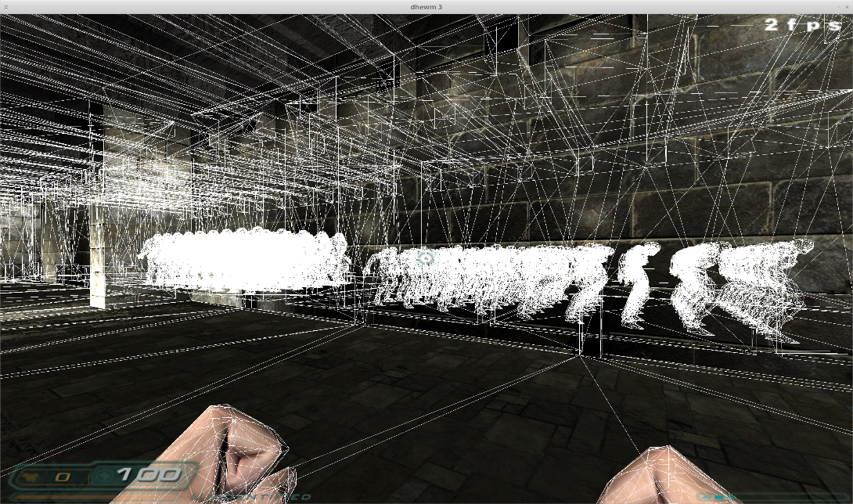

[Figure 2] Map with r_showTris 3 command enabled allowing the viewing of all Wireframes in the map.

Without performing any changes to the files, the build time takes about 5-10 mins to build in Doom 3. However, with the implementation of each of the changes that are supposed to be applied the build time should decrease a bit. Below is another screenshot of the custom map designed this time it is shown in its text format.

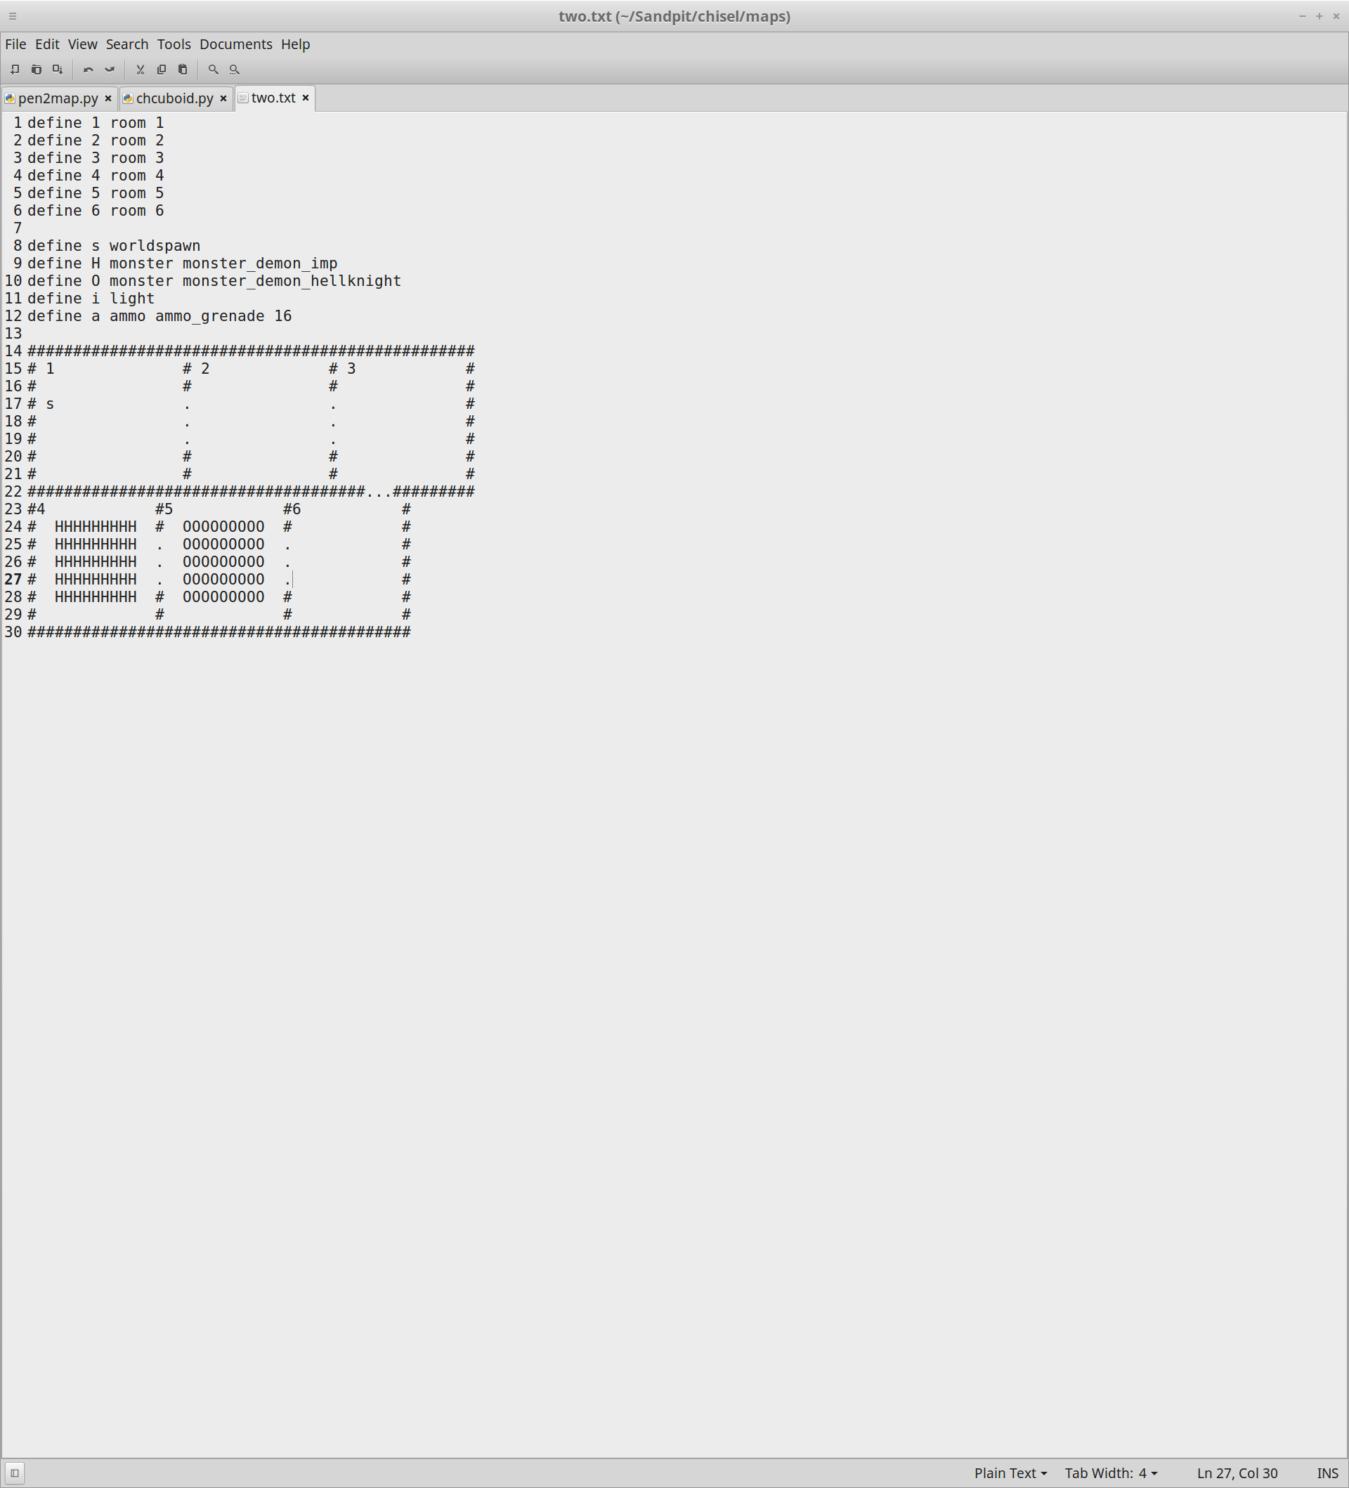

[Figure 3] The custom map created in text file format.

Explanation of Vis Portals:

Vis portals are a brush tool created by id software that separate the map into individual areas which are called visleafs and renders other visleafs depending on whether or not they are in viewable range of the one that is currently occupied. The importance of creating this simple tool means that a game like doom that consists mostly of just rooms can only render those rooms instead of the whole of the current map, decreasing the strain on the engine. The downside to this tool is that it is only useful in games that employ this method of map design and others involving huge open spaces with complex scenes would hardly benefit at all from this. The way vis portals work is by creating planes in doorways of rooms to define which areas can be viewed and therefore should be drawn from the current room. How this check occurs is by looking from all areas in the room the player is in and checking how many rooms are visible from that room. For example, in the Figure 3 custom map from the spawn point in room 1 by enabling vis portals we should be able to see into room 2 and room 3 and possibly room 6 however, rooms 4 and 5 will not be drawn as no part of either of these rooms can be seen from room 1’s doorway.

Implementation of Vis Portals:

The implementation of the vis portals in the pen2map.py code is shown in the Figure 4 screenshot. The problem with the implementation in the assignment was not working out the view angles as the engine handles that in the vis portal tool created by ID in the engine. The problem was applying the vis portals to the existing door frames so that they activate the already in engine vis portal code correctly. There were some issues that caused some difficulty when trying to apply this code which involved the mathematics required to calculate the exact positions that we should place the edges of the vis portal planes in that would work for each door both horizontal and vertical. Another issue was converting an understanding of the maps from 2D to 3D space, while this is not a technical issue it is worth mentioning as a highlight to the complexity of understanding the code. This problem occurred when understanding the transference from a 2D map into a 3D one as the code in pen2map looks at building the 3D map from a 2D text file so in the code it takes some time to properly grasp which point is being looked at when checking the doorways.

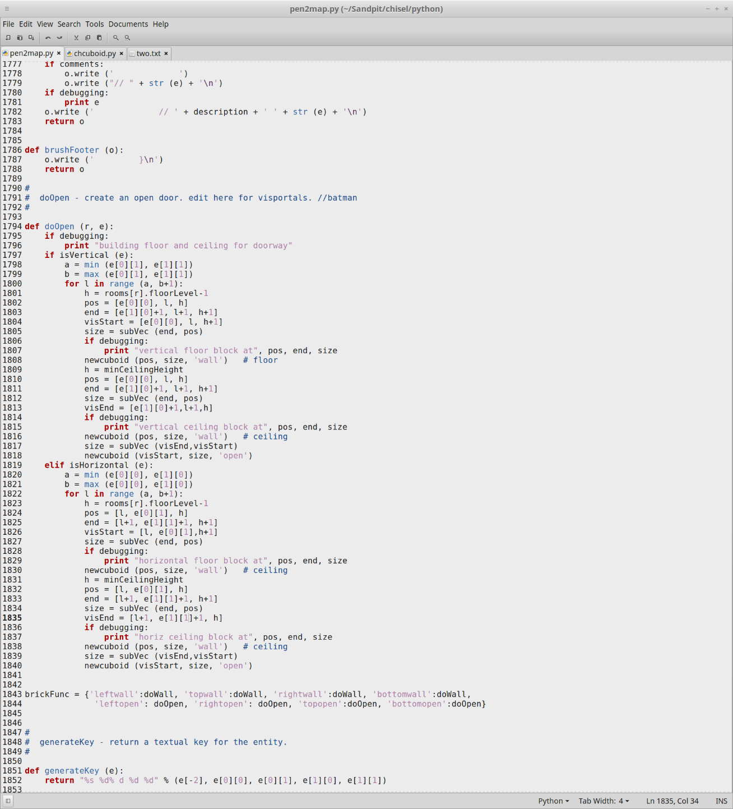

[Figure 4] This image includes the code added for the vis portals to work correctly.

The code involves setting the start and end points for the vis portals in the bottom left and top right frames of the doors. The code shows that the in the vertical and horizontal code the first coordinates that must be found is the bottom left as indicated by the visStart variable which is an array set out with e, l and h which stand for the x, y, number of sections and z coordinates of the door. For the plane to be placed these positions need to be filled out as the example of the vertical visStart shows the x and y for e uses 0 for both, the number of sections for l doesn’t change and the z axis for h is set to touch the ground. The same must be completed for visEnd as was done for visStart except for the top right corner instead of the bottom left. Finally, a newcuboid must be created using the start and size of the vis portal and the declaration of open to define that the created object is a vis portal. Currently the code only works with open doors so, if other variations of doors were to be added into the pen2map conversion then the code would have to be adapted to accommodate for them. The below diagram will further show how the portals positions are found.

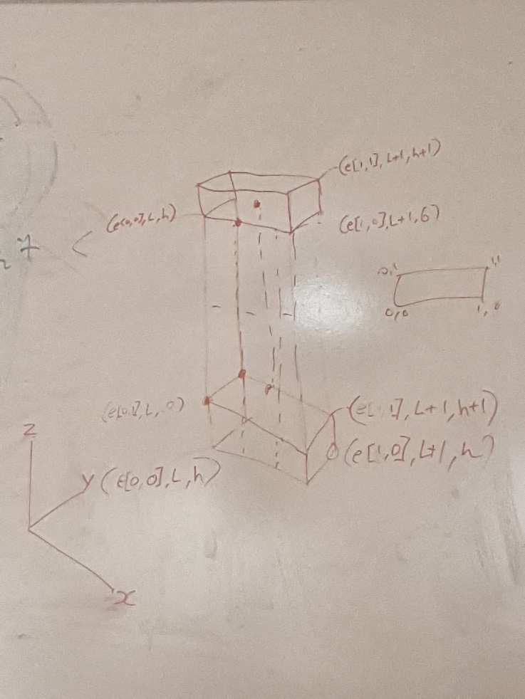

[Figure 5] Diagram showing how the doorways are set up to find the positions to place the visportals.

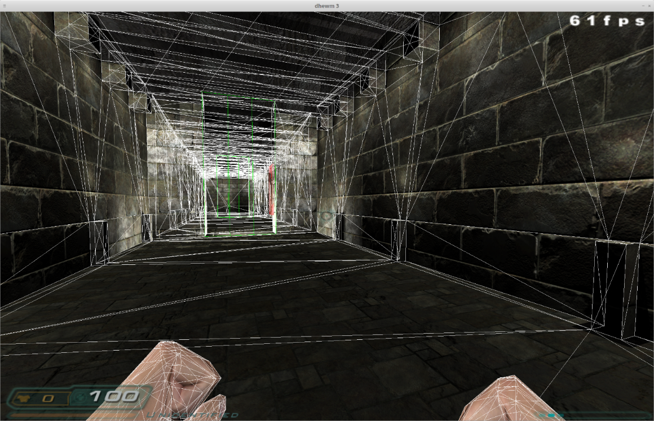

[Figure 6] This screenshot shows the custom map running with the vis portals active and the commands r_showTris 3, r_useScissor 0 and r_showPortals 1 active.

The useScissor 0 command is used for testing vis portals, the command disables any non-viewable room triangles that are enabled with the showTris 3 command in order to show which rooms are being drawn through the vis portals and which rooms aren’t. The showPortals command is also to do with vis portals which makes them visible on the doorways as shown in the screenshot, the command draws 2 different versions of the vis portals depending on their position. Green doors are doors the player can see through into the next room and red doors are doorways the player cannot see through from their position.

Since the map created is my own custom map which renders 90 enemies we can see that the vis portals not only reduced the time it takes to build this map from 10-15 minutes down to about 1-2 minutes. It also shows that the vis portals work properly and are not rendering the rooms with the enemies in them as evidenced by the fps being at 60 instead of at 2 fps it was at before. The downside to the vis portals is that all enemy sounds are completely disabled until they are rendered which for a horror action game is a slight design problem.

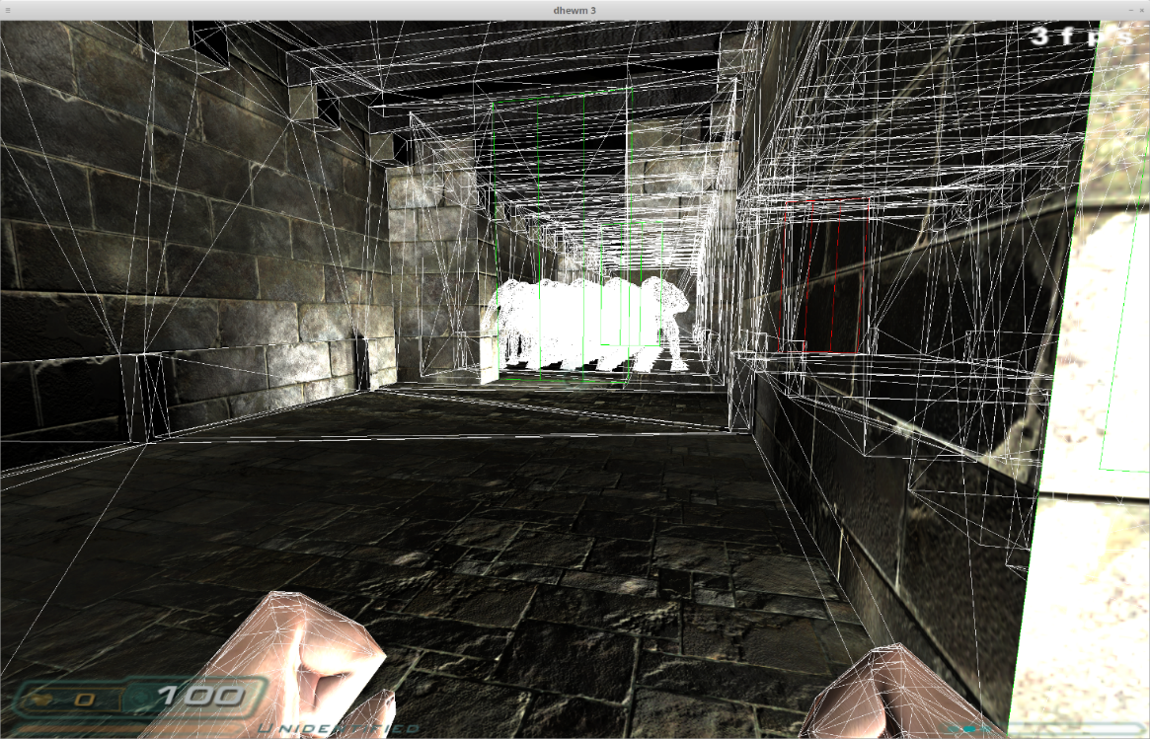

[Figure 7] This screenshot shows what happens after entering the vis portal and into the room that can see through into the rooms with the enemies in them. As the screenshot shows the first room that the player spawns in has a red vis portal that can’t be seen through and the fps drops down to about 3 due to the number of enemies being rendered to the screen.

Make Switchable:

To switch the Visportals on and off the handleOptions that are used in a terminal call must be changed to allow for different additions that will let me enable and disable all of the optimisations. To start with I added in some changes to the code added over the part 1 and part 2 as shown in the screenshots below.

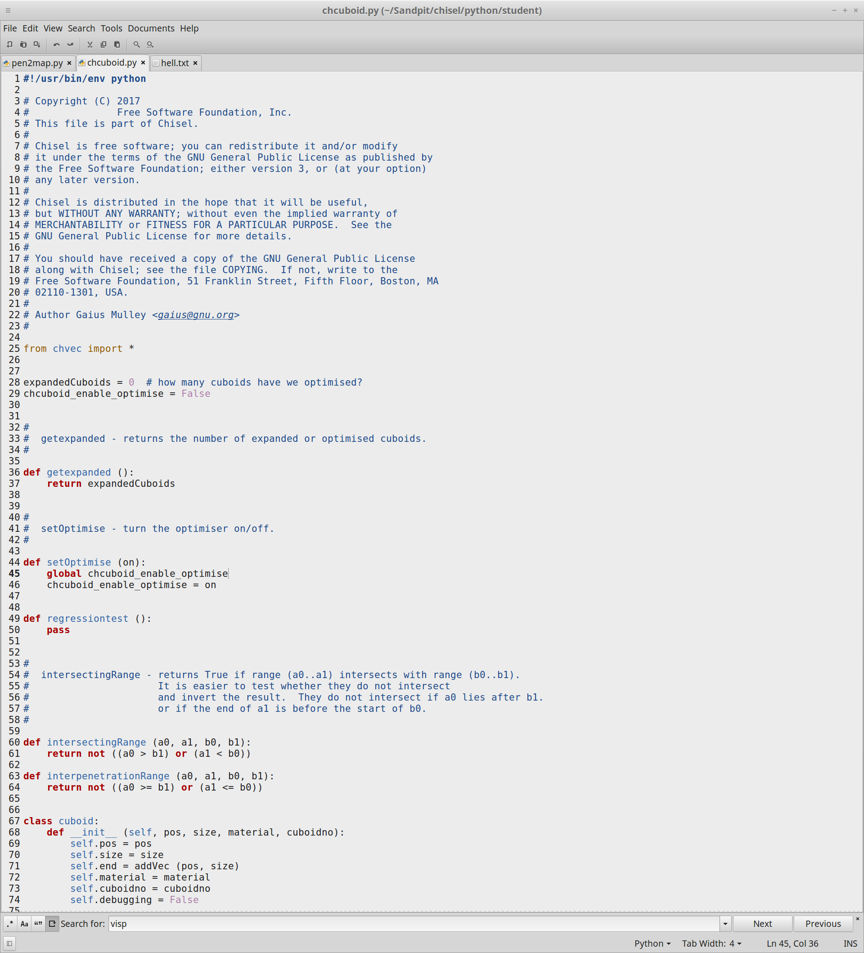

[Figure 8] The chucuboid.py file was changed so that the optimisation was false

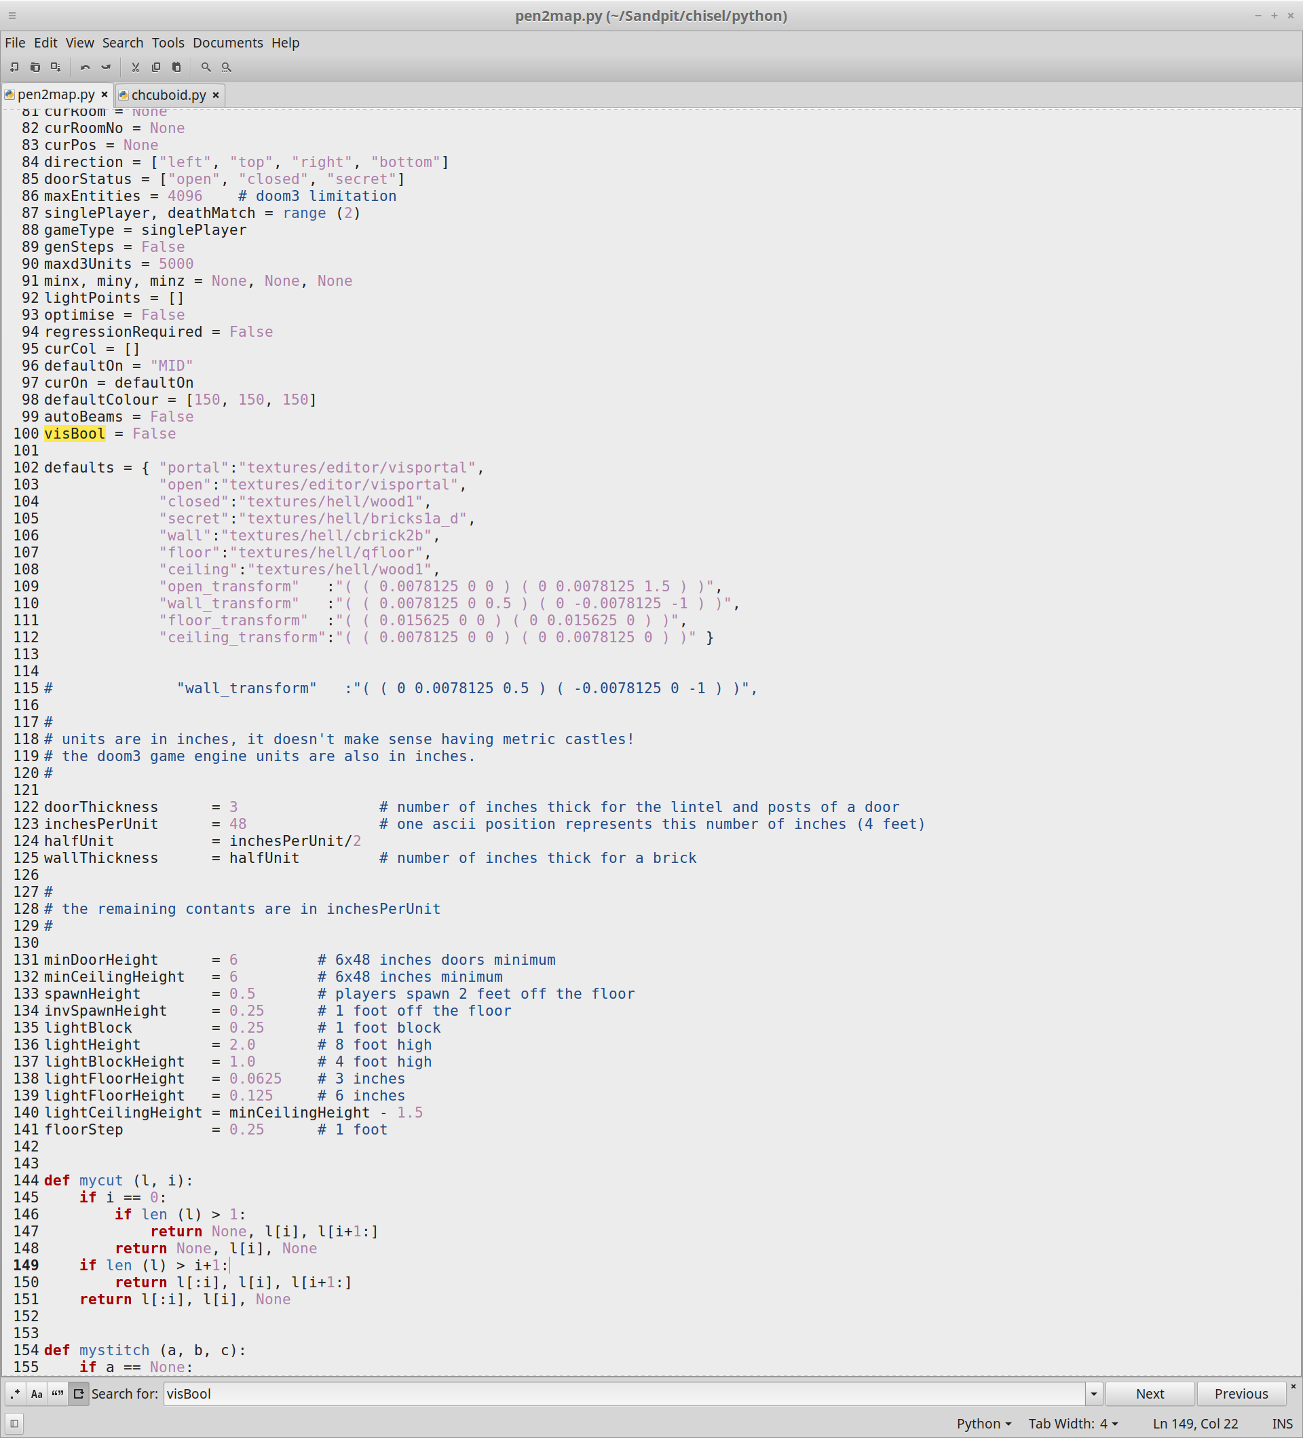

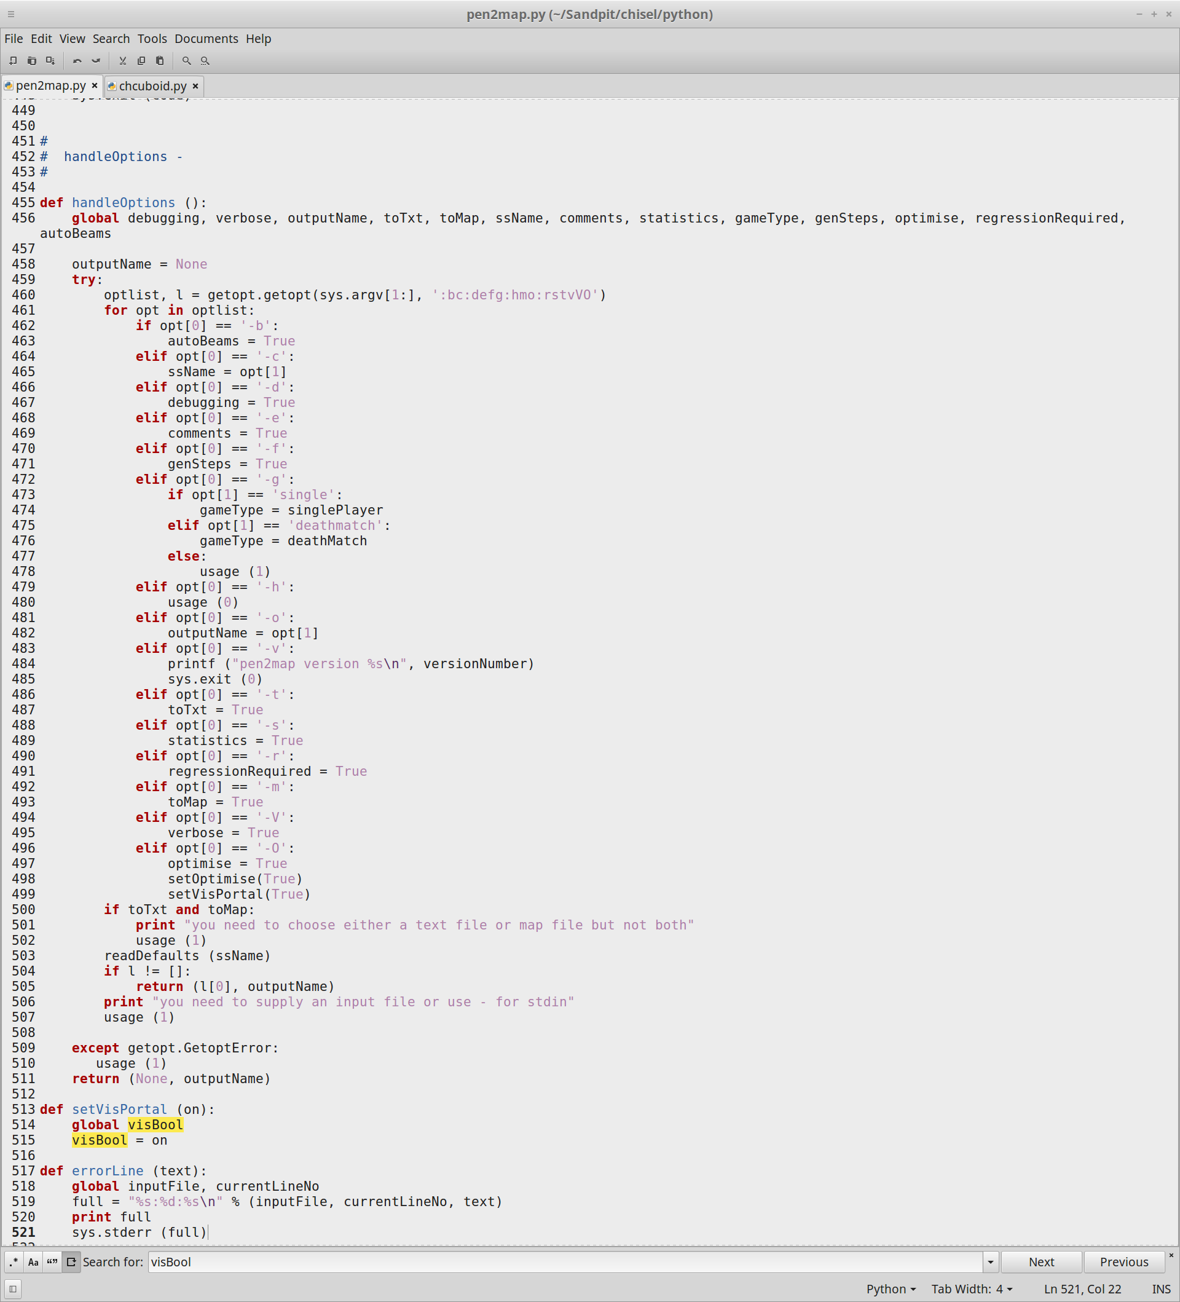

[Figure 9] this joint screenshot shows the setting up of the visBool and switch that will be used to turn the visportals on and off.

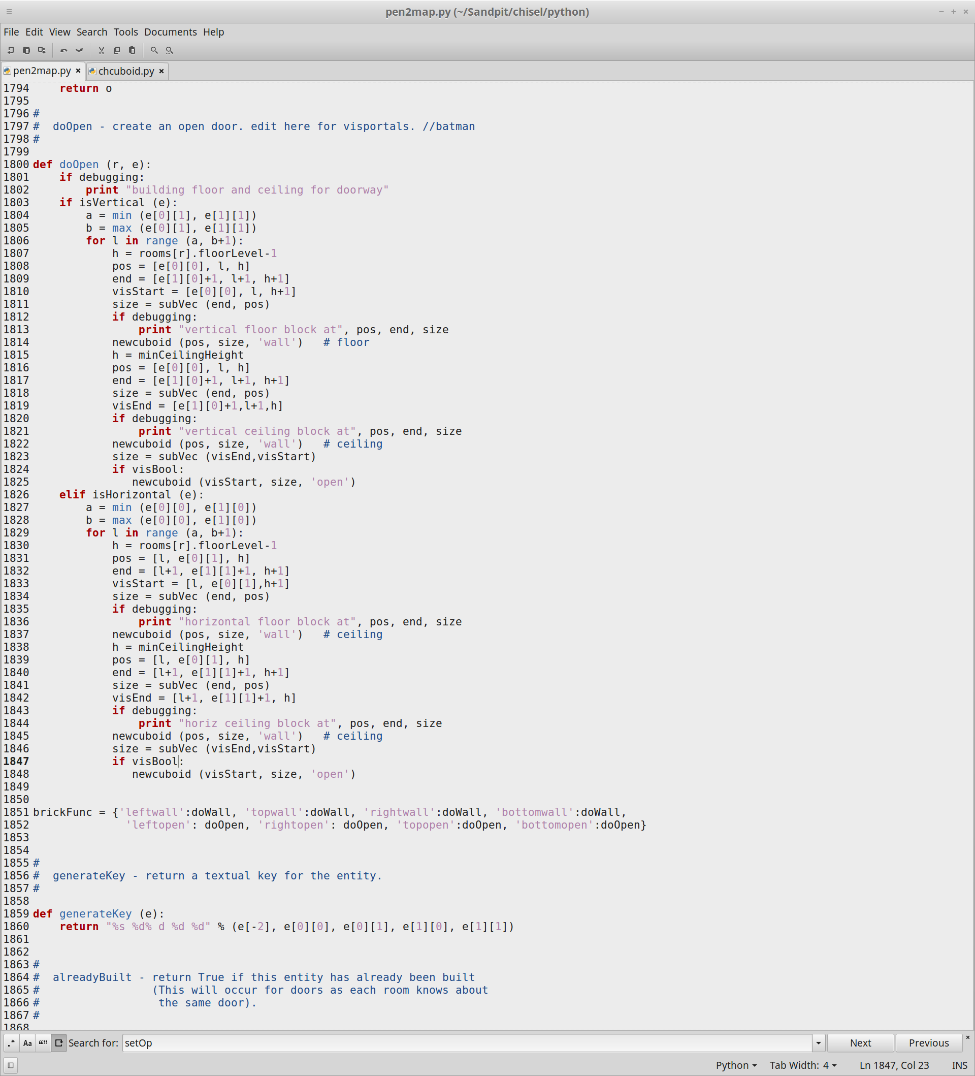

[Figure 10] This screenshot shows the new doOpen function with the visportal switch check to run the visportal code if the setVisPortal is true.



[Figure 11] This screenshot shows the code that adds the terminal line addition to pen2map.py under the -O line addition that sets various optimisation options to True such as the cuboid optimisations and the Visportals.

Finally, to make the code work the developer-txt2map file was changed to include -O in the command it would run and then it was saved as opt-txt2map so that both exist and can be run as needed. Below includes 2 screenshots of the original file and the edited file.

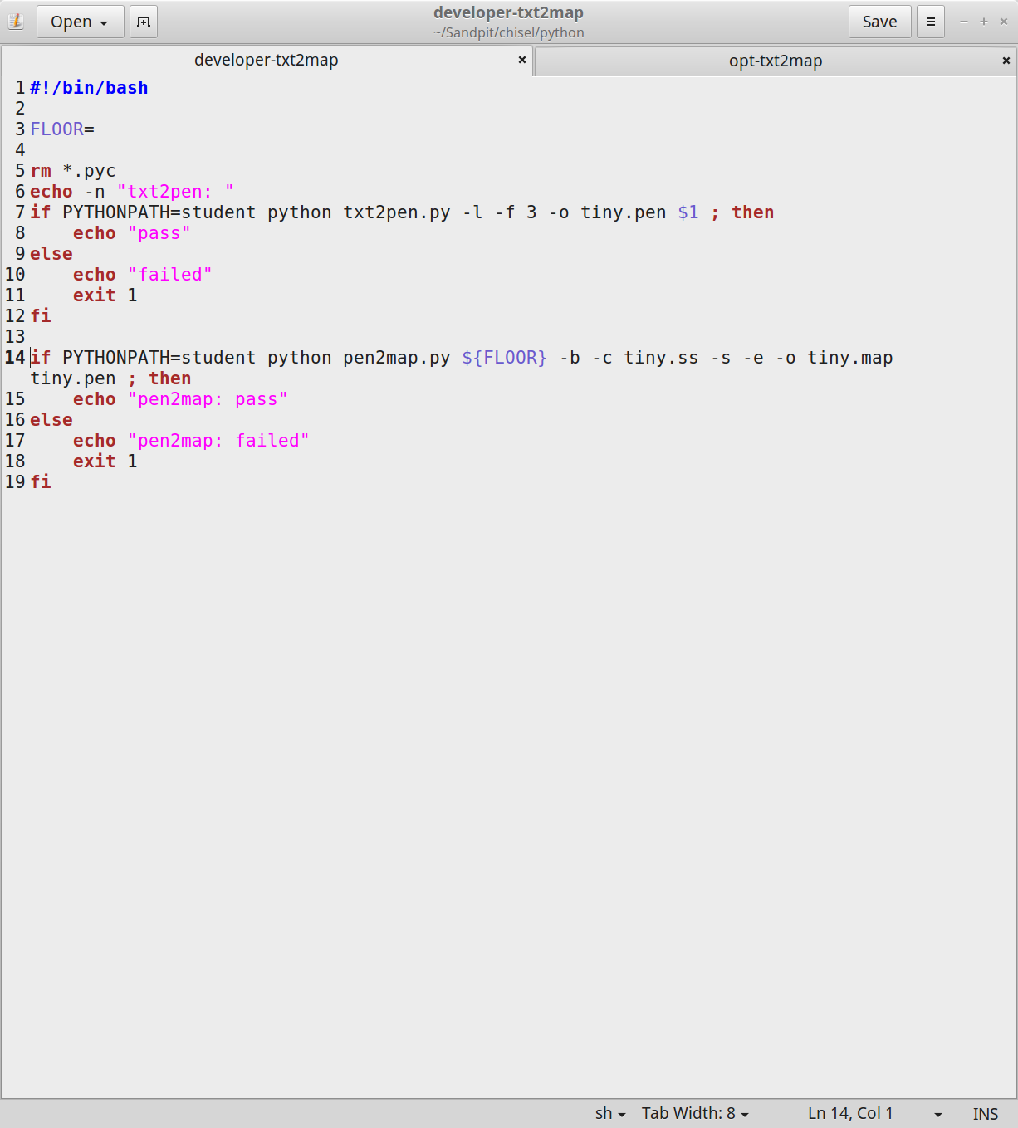

[Figure 12] Screenshot showing the original developer-txt2map file

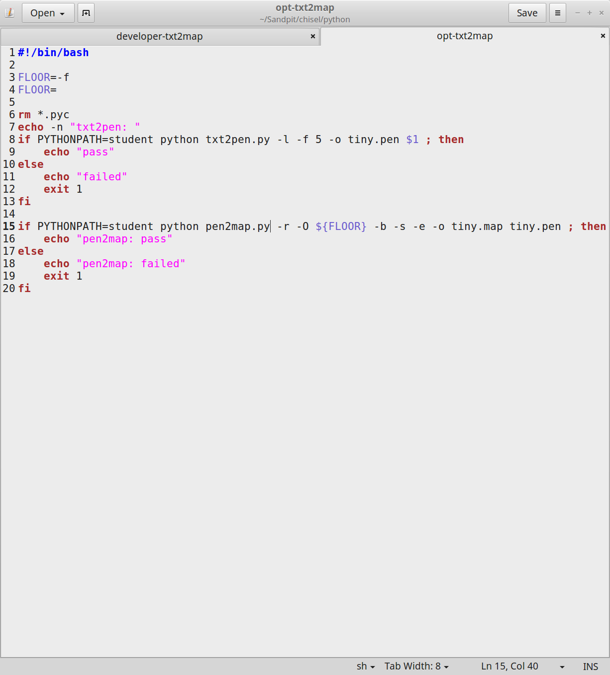

[Figure 13] Screenshot showing the modified opt-txt2map file that includes the -O line option

The commands that are needed to run each of these files is as shown below:

./opt-txt2map ../maps/MapName.txt

./developer-txt2map ../maps/MapName.txt

Different Z Heights:

Adding Z heights into chisel means creating different heights between rooms to create steps that give the levels mor depth and design. There are multiple ways to do this the most simple way which I have implemented involves moving the floorlevel depending on the room that is being drawn, for example I have made it so that every even numbered room has a step between it and an odd numbered one. The screenshots below show how the level is edited and the code that edits it.

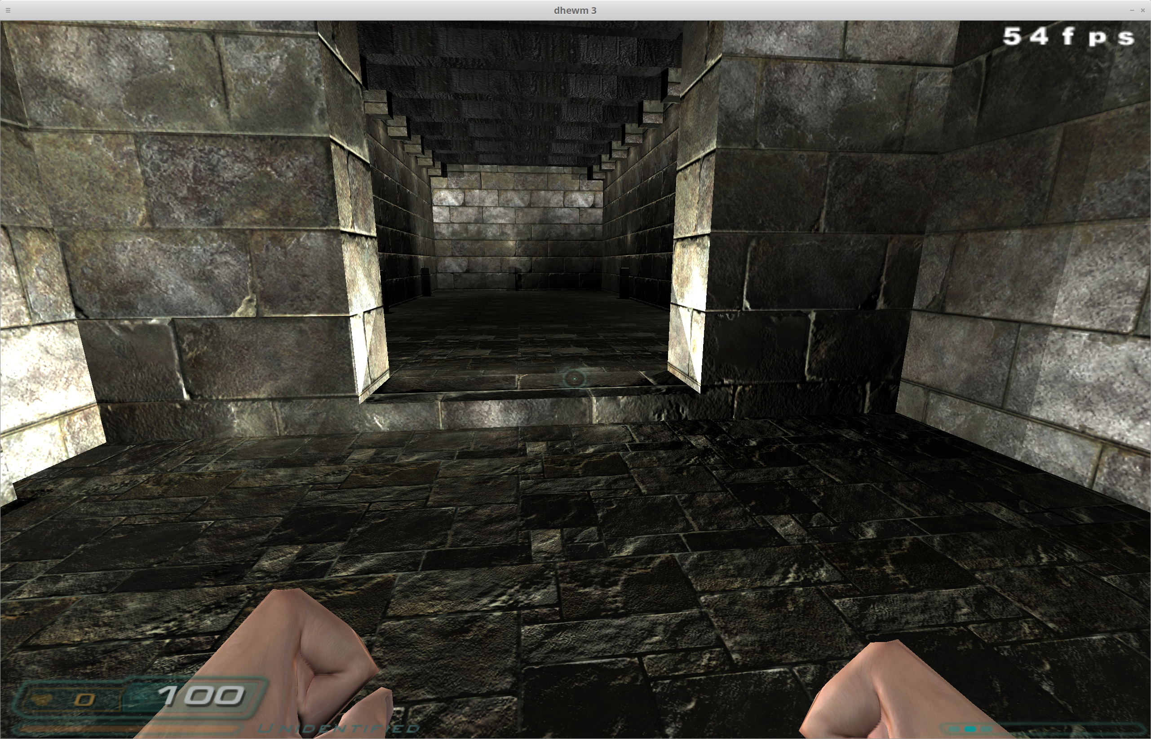

[Figure 14] Shows the difference in the floor heights between rooms

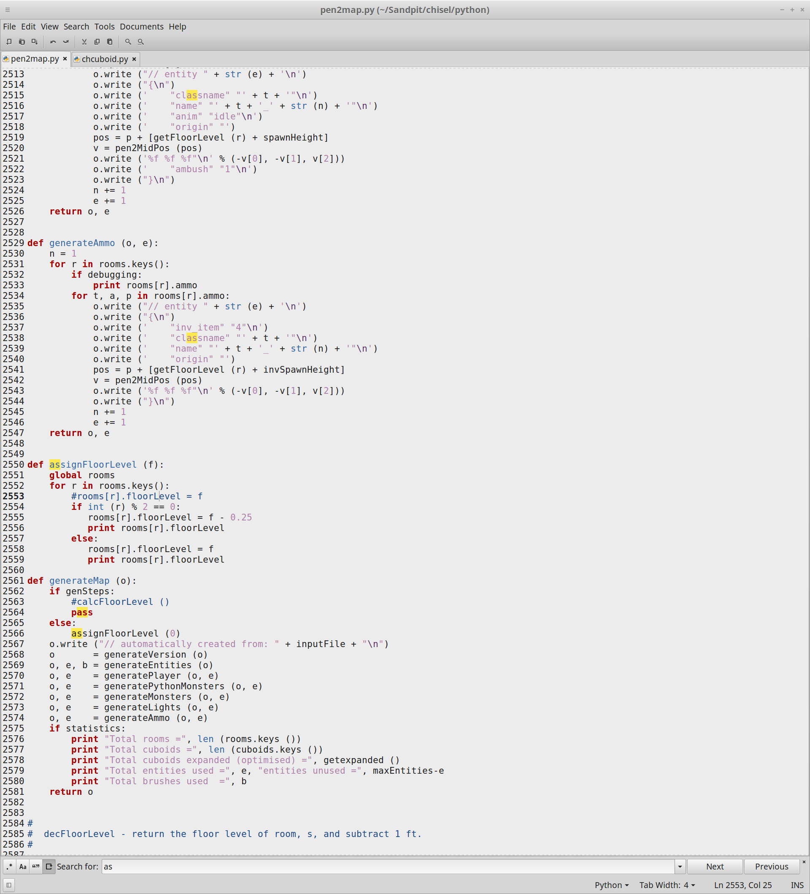

[Figure 15] Shows the code that is used to find whether the number of the rooms is odd and edit of the floor level of even rooms to a lower height. The screenshot also shows the function that calls the floor level adjustment function.

The more complex way to implement different Zheights is to use a breadth first search algorithm which would allow for larger difference in the Zheights and allow for more and larger stairs between rooms which would dramatically increase the feel of the game and bring it closer to looking like the original doom.

**Part 2: Chisel Optimisations**

The optimisations to chisel that were to be added involved using code that would check through and check for any cuboids that are in the same area and of the same size and connect them together to reduce the number of cuboid brushes used. The reason for performing this change is that at current there is a finite number of brushes that can be used when creating maps and when hitting that limit it can cause all sorts of problems in the engine. However, should some of the cuboids that are in similar proximity to others be combined then it would reduce the overall number of brushes used allowing in the creation of larger and more complex maps. The screenshot below will include an image of the terminal with no optimisation included so that a comparison can be made at the end.

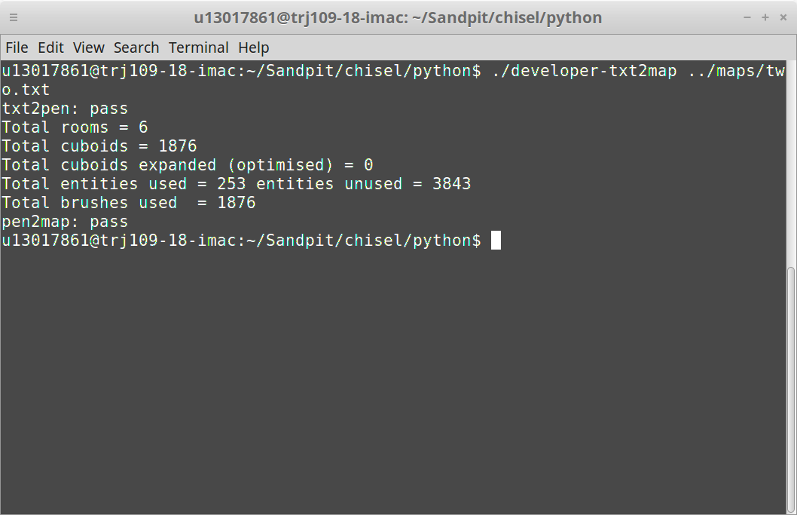

[Figure 16] This screenshot shows the terminal running without the optimisation. As shown in the screenshot the number of optimised cuboids is 0 which would mean that no cuboids are being combined yet.

The next few screenshots will show the additions and the edits to the file as well as the result achieved when running the completed code.

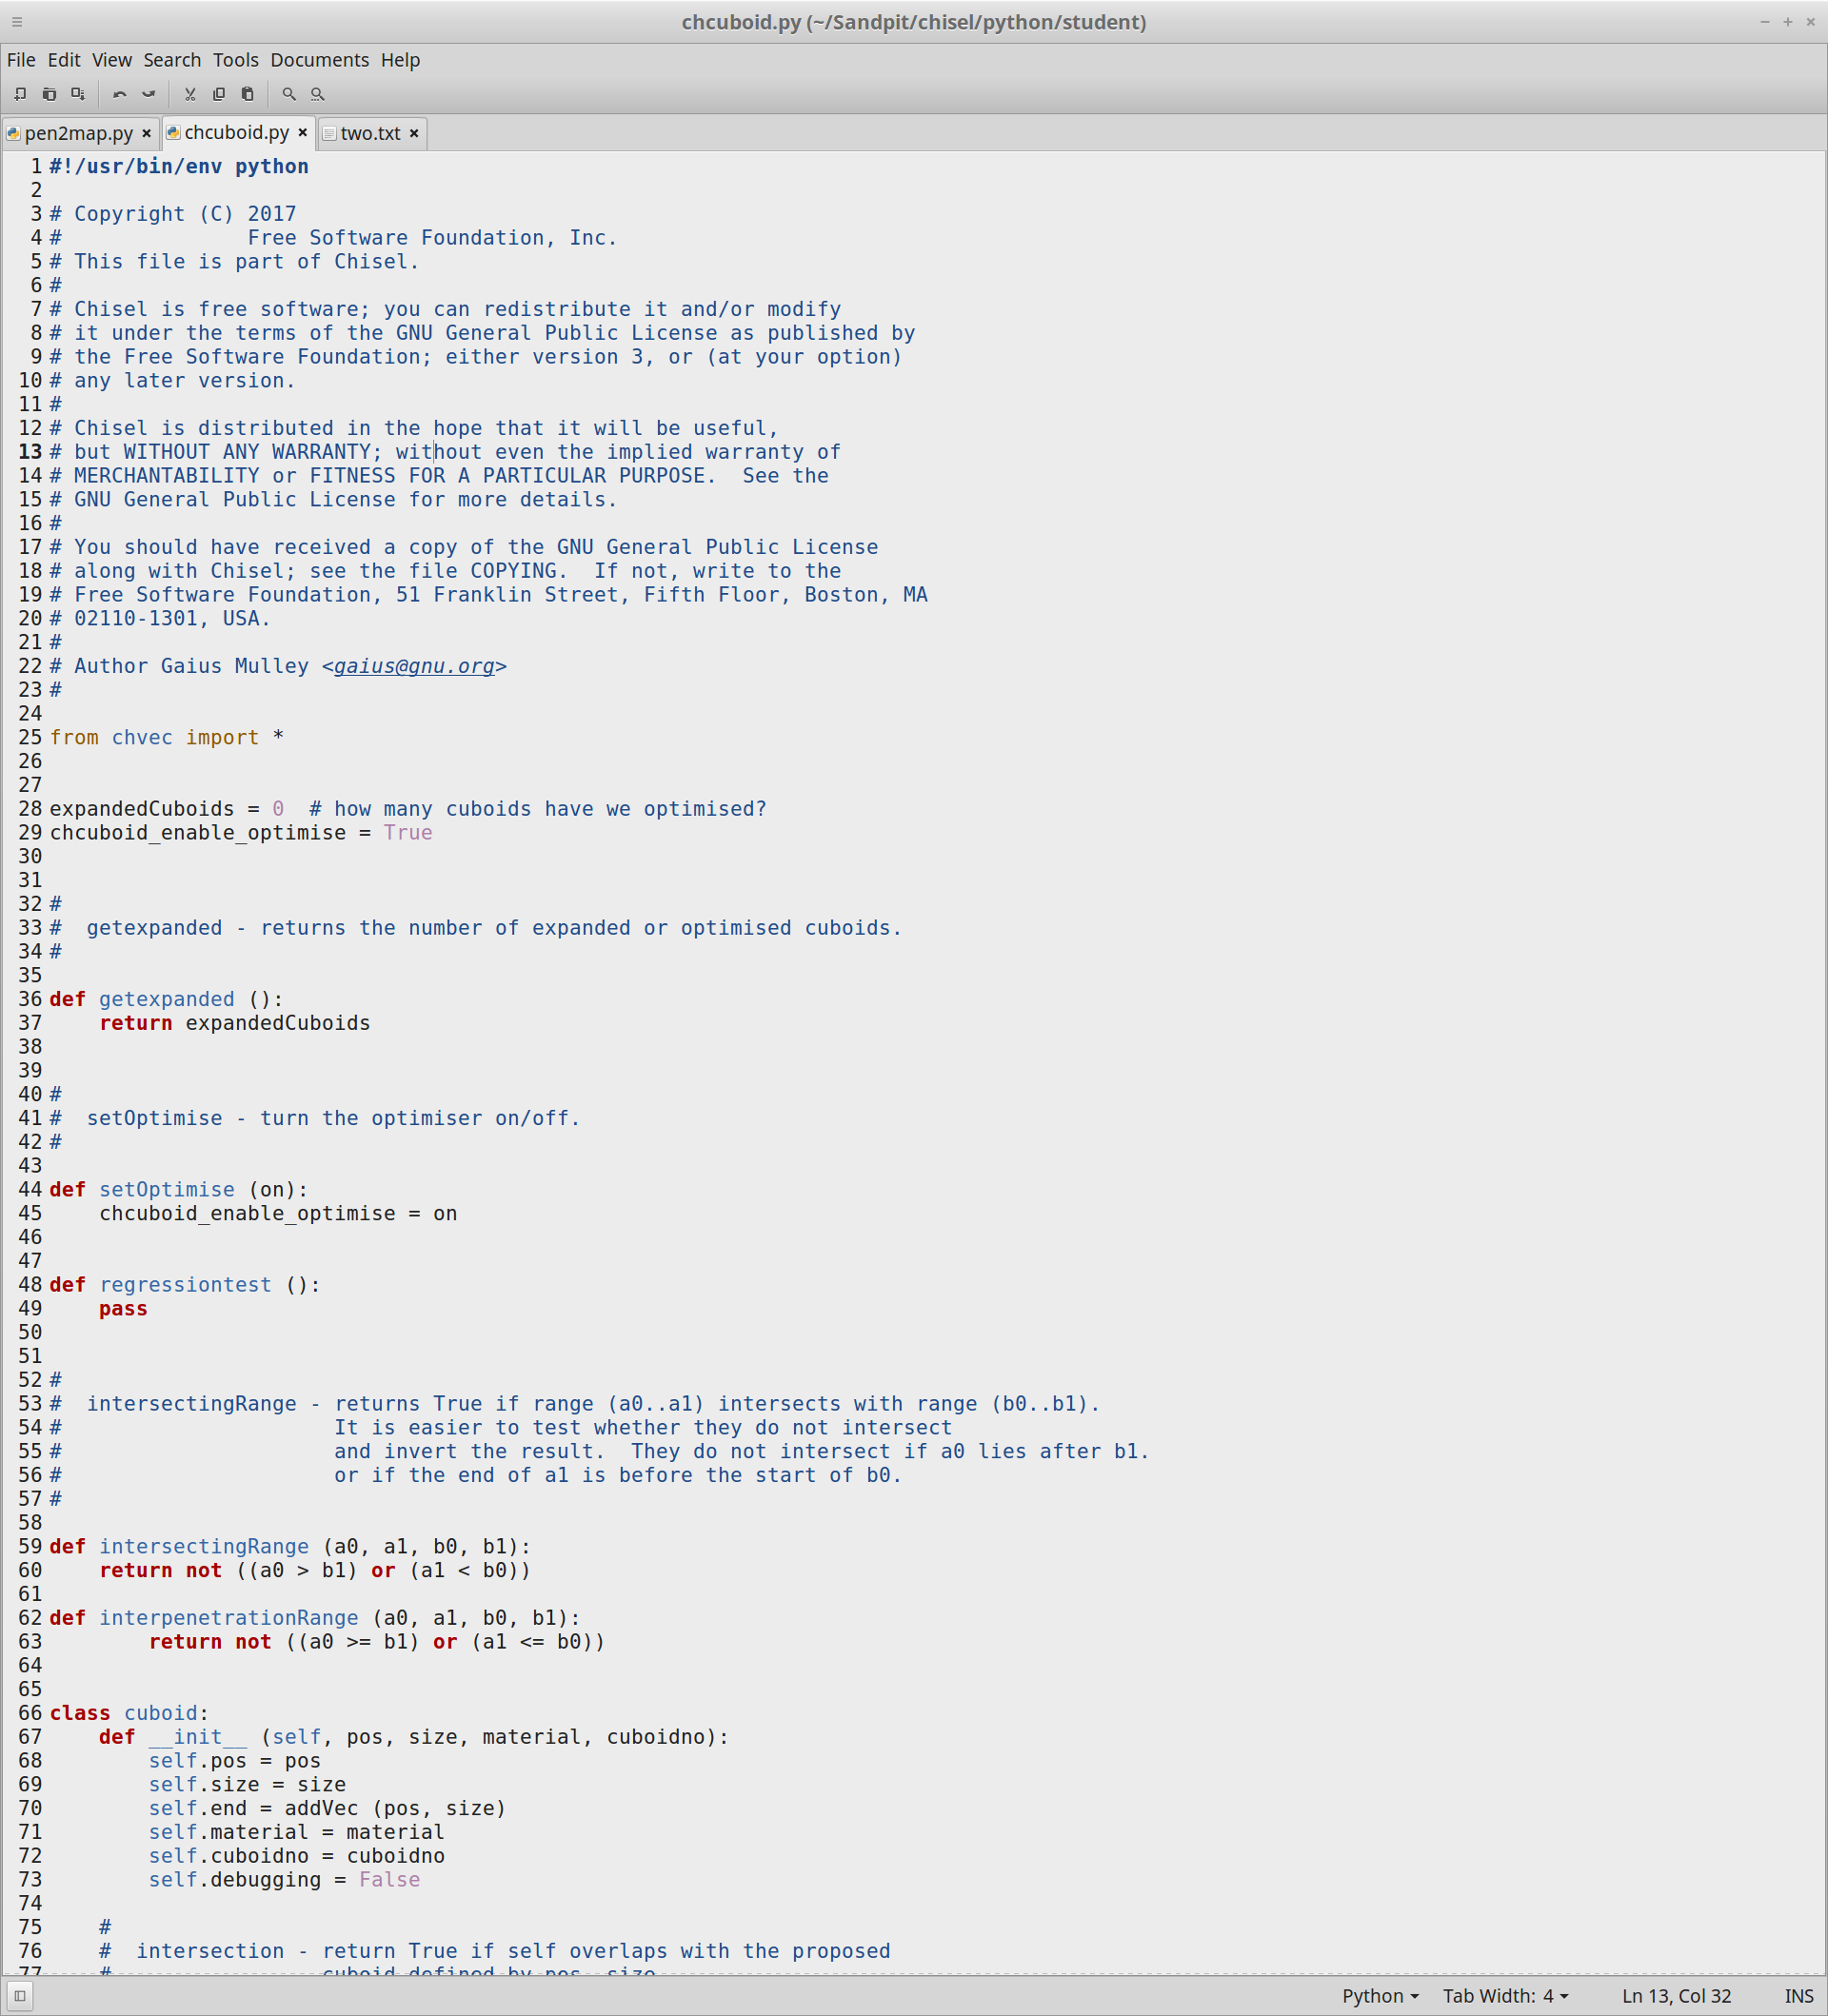

[Figure 17] This screenshot shows the beginning of the edited file which includes changes to enable the optimisation and includes the addition of the interpenetrationRange which is a slight variation in the maths of the intersectingRange. Both definitions will be used later when we need to find the intersecting and interpenetrating axes.

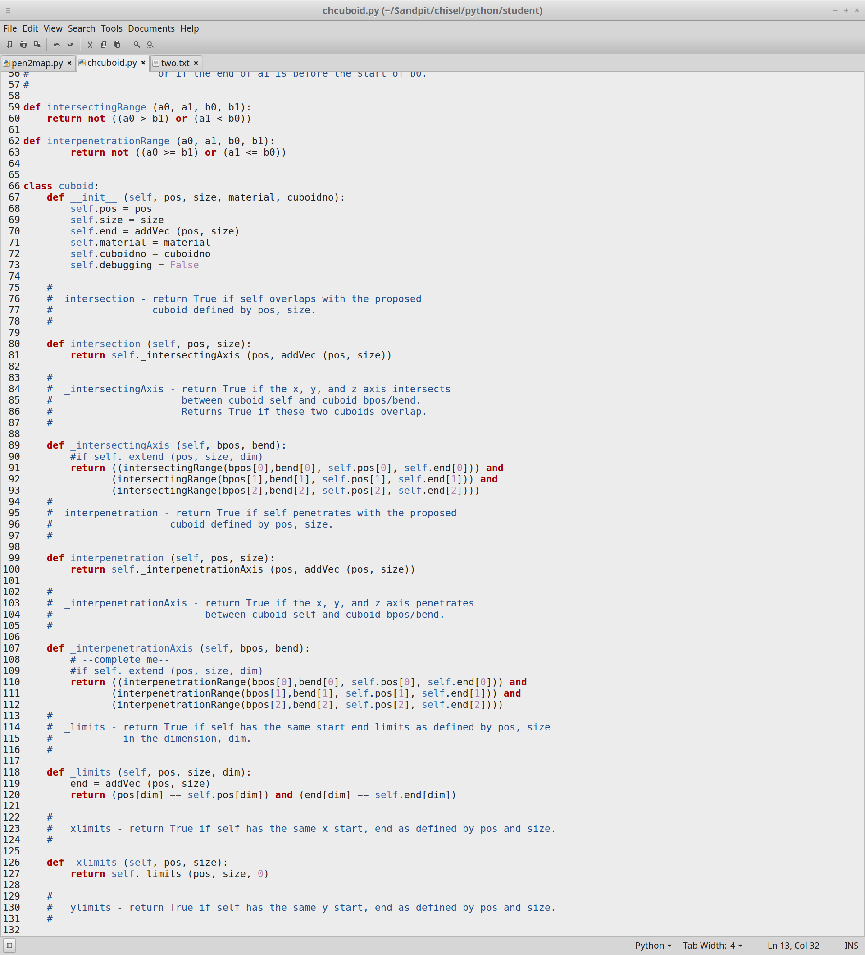

[Figure 18] This screenshot shows the use of interpenetration and intersecting ranges to find the axes. As the code shows we want to return if these cuboids intersect or interpenetrate to decide on whether we want to merge them or not.

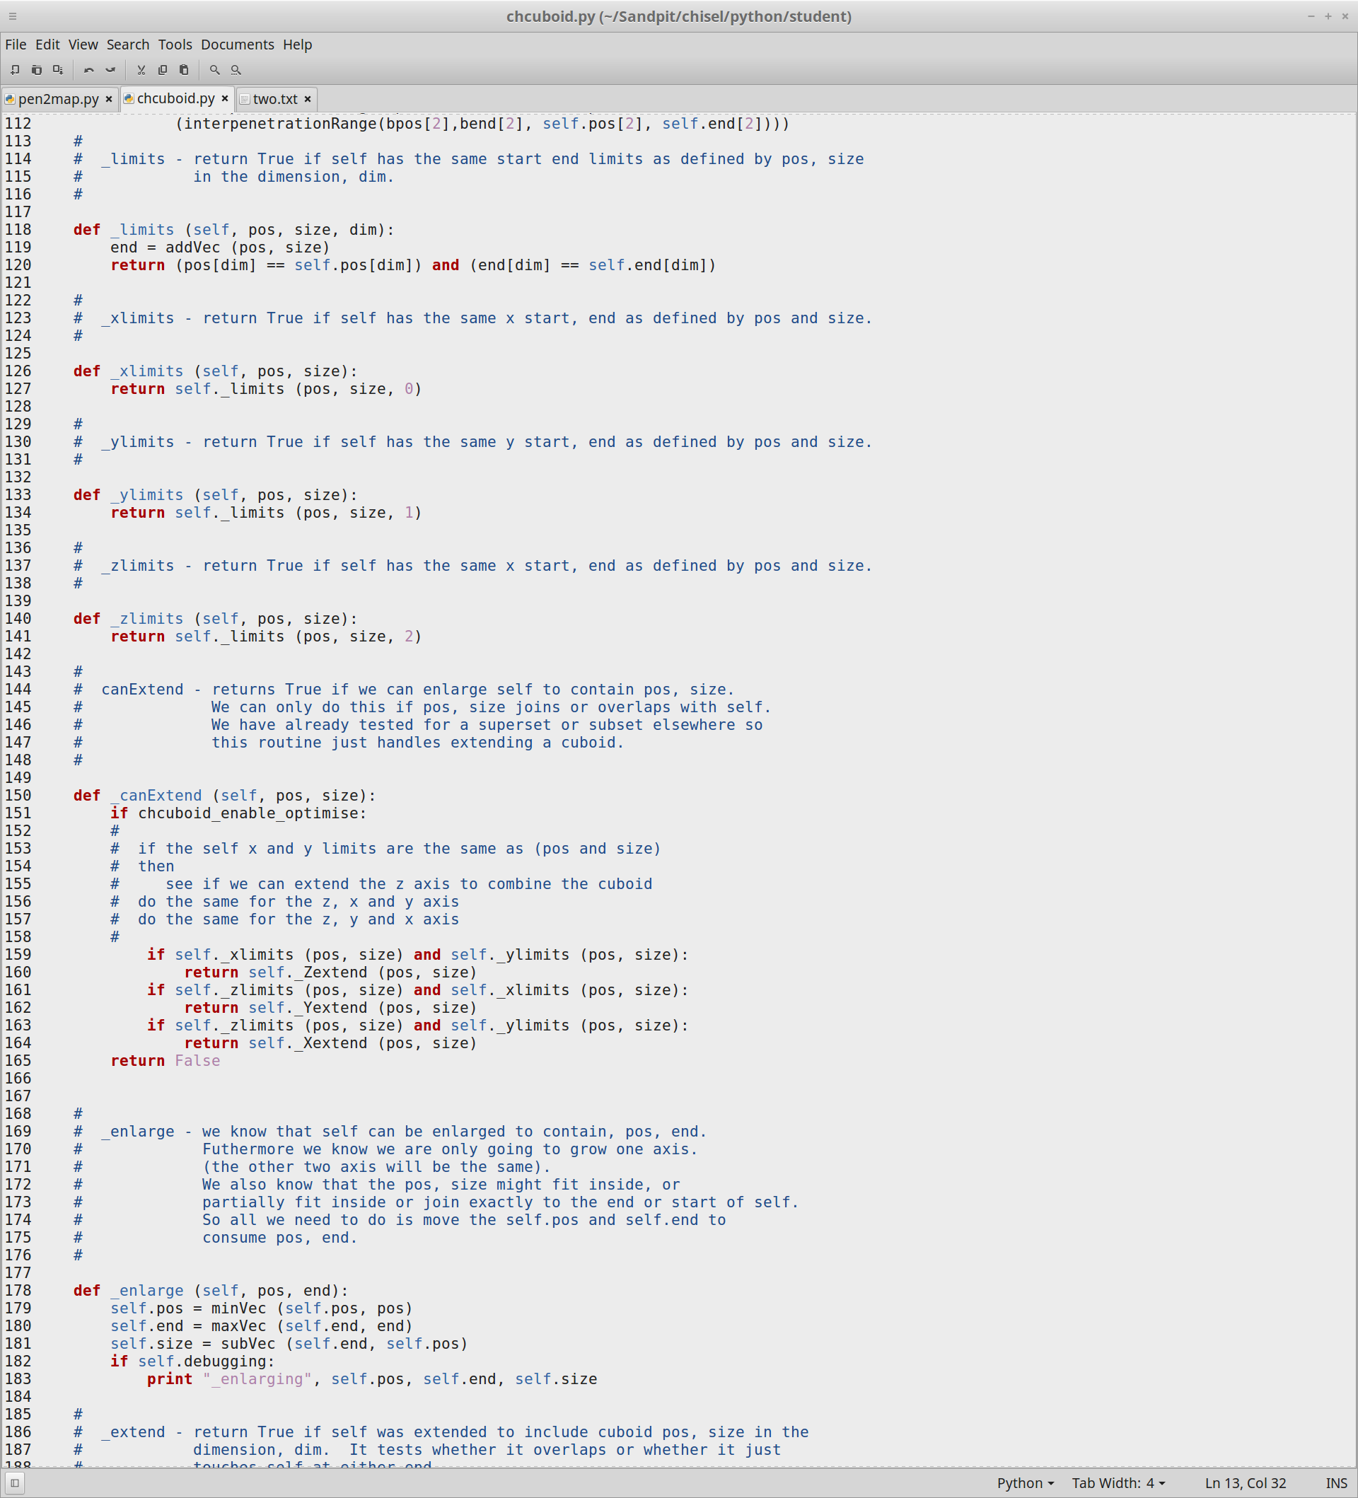

[Figure 19] If we run the enable optimise code and we find cuboids that fit the parameters that we have set above on the x, y or z axes then we can combine the cuboids to reduce the amount of brushes used.

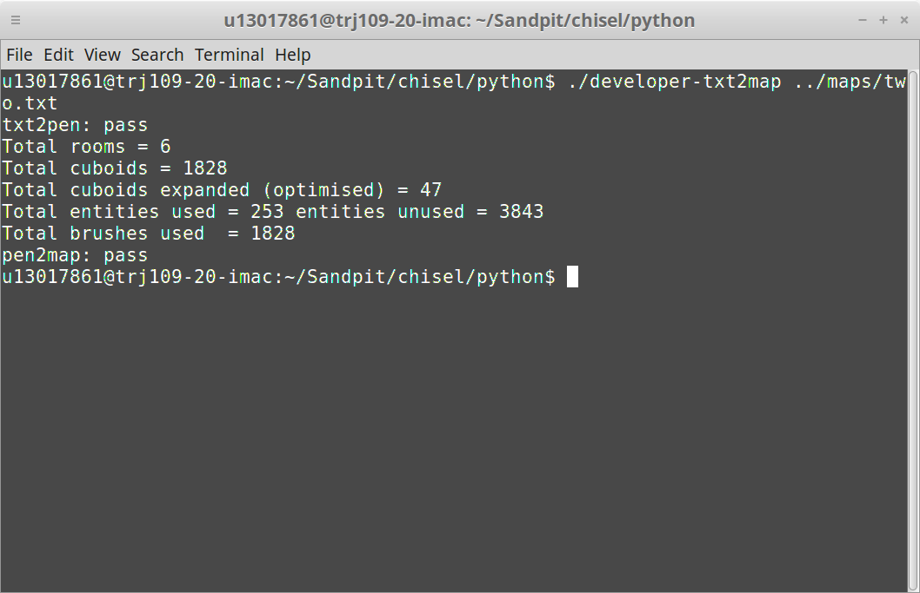

[Figure 20] This is the first test run after adding the optimisation code for the cuboids.

Since there is no visible difference within the levels that show the cuboids being drawn we must check the results in the terminal. As the terminal above shows us there is now some optimised cuboids in the custom map I have created however, as this is a very small map there is only a few cuboids that can be optimised. The next thing to do will be to run some more tests on some other larger maps to see it working better.

**Part 3: Usefulness and Further Improvements**

Usefulness:

There are numerous positive points for creating maps in doom 3 using this tool the most obvious ones are that making maps themselves is very simple, quick and easy to understand which makes it very accessible to anyone that wants to make maps for doom 3. Further positive points for this tool would be that the tool is very customisable in the fact that any letter or symbol can be used to define an object (except for a few) and then used in the map as many times as the map can hold.

The problems with using this tool to create the maps is that they can end up very similar and plain, the textures can be changed but as the map is 2D converted to 3D it would be very difficult for someone to create things like jump pads that work effectively and lifts would be impossible to add onto a 2D map. Another problem with the tool is that is can only be used to create rooms which are of a cuboid shape, in other words circular or diagonal creations are impossible to create with this tool.

Further Improvements:

Future improvements that can be added to this tool are: -

Further improvements to the Visportals which would include a fix that stops the problem occurring with the current Visportals that stops them being drawn at the same location as another. Which could be fixed with some changes to make the visportals 3D instead of planes and further measures could be added to make sure only one is drawn per doorway.

Addition of things like jump pads and platforms this would involve increasing the ceiling height to accommodate the jump pad and assigning an object for the platform as well as a set height for it. This might not work at all and might cause problems when trying to define a height for the object. Creating empty space hazards in the floor might also not work and instead the ceiling might have to be removed for the player to be flung between rooms instead.

Open sky spaces which would include adding in a skybox texture for effect and possibly some terrain areas to increase the visual effect, however this may also not be possible unless everything outside of the rooms could defined as terrain.

Increasing of the maximum amount of brushes available/reducing the brushes used this improvement would come in handy should you want to create bigger maps. This can be done by further optimising the cuboids to increase the amount that are optimised in order to circumvent the limitations of the doom 3 engine and the amount of entities it is limited to draw.

Another improvement could include adding windowed walls so that rooms can be viewed through other rooms by means other than doors. This could be achieved by adding in a different type of walls in the code that include a hole in the middle. In addition this could also help with secret doors that would allow the player to see the hidden areas and have to work out how to get in there.

It might be possible to multiple floored rooms by creating multiple map files with clear entry points and joining them up, then using altering the cod eso that it loads multiple files at once and loads them together.

Appendix:

git diff -

diff --git a/maps/two.txt b/maps/two.txt

index 7abf8b8..91c6998 100644

--- a/maps/two.txt

+++ b/maps/two.txt

@@ -1,18 +1,30 @@

-

define 1 room 1

define 2 room 2

+define 3 room 3

+define 4 room 4

+define 5 room 5

+define 6 room 6

+

define s worldspawn

-define o monster monster_demon_imp

-define n monster monster_demon_hellknight

+define H monster monster_demon_imp

+define O monster monster_demon_hellknight

define i light

define a ammo ammo_grenade 16

-##################################

-# 1 i # 2 i #

-# o # #

-# s . #

-# . #

-# . #

-# # g n #

-# i # i #

-##################################

+#################################################

+# 1 # 2 # 3 #

+# # # #

+# s . . #

+# . . #

+# . . #

+# # # #

+# # # #

+#####################################...#########

+#4 #5 #6 #

+# HHHHHHHHH # OOOOOOOOO # #

+# HHHHHHHHH . OOOOOOOOO . #

+# HHHHHHHHH . OOOOOOOOO . #

+# HHHHHHHHH . OOOOOOOOO . #

+# HHHHHHHHH # OOOOOOOOO # #

+# # # #

+##########################################

diff --git a/python/chvec.pyc b/python/chvec.pyc

index 01dd27f..d3157aa 100644

Binary files a/python/chvec.pyc and b/python/chvec.pyc differ

diff --git a/python/opt-txt2map b/python/opt-txt2map

index f8b2033..db2a4bc 100755

--- a/python/opt-txt2map

+++ b/python/opt-txt2map

@@ -5,14 +5,14 @@ FLOOR=

rm *.pyc

echo -n "txt2pen: "

-if PYTHONPATH=../../solutions python txt2pen.py -l -f 5 -o tiny.pen $1 ; then

+if PYTHONPATH=student python txt2pen.py -l -f 5 -o tiny.pen $1 ; then

echo "pass"

else

echo "failed"

exit 1

fi

-if PYTHONPATH=../../solutions python pen2map.py -r -O ${FLOOR} -b -s -e -o tiny.map tiny.pen ; then

+if PYTHONPATH=student python pen2map.py -r -O ${FLOOR} -b -s -e -o tiny.map tiny.pen ; then

echo "pen2map: pass"

else

echo "pen2map: failed"

diff --git a/python/pen2map.py b/python/pen2map.py

index da6fab5..df510a4 100644

--- a/python/pen2map.py

+++ b/python/pen2map.py

@@ -97,6 +97,7 @@ defaultOn = "MID"

curOn = defaultOn

defaultColour = [150, 150, 150]

autoBeams = False

+visBool = False

defaults = { "portal":"textures/editor/visportal",

"open":"textures/editor/visportal",

@@ -494,6 +495,8 @@ def handleOptions ():

verbose = True

elif opt[0] == '-O':

optimise = True

+ setOptimise(True) #handle option that will be used to turn the optimisations on

+ setVisPortal(True)

if toTxt and toMap:

print "you need to choose either a text file or map file but not both"

usage (1)

@@ -507,6 +510,9 @@ def handleOptions ():

usage (1)

return (None, outputName)

+def setVisPortal (on):

+ global visBool

+ visBool = on # Switch to turn visportals on and off

def errorLine (text):

global inputFile, currentLineNo

@@ -1788,7 +1794,7 @@ def brushFooter (o):

return o

#

-# doOpen - create an open door.

+# doOpen - create an open door. edit here for visportals. //batman

#

def doOpen (r, e):

@@ -1801,6 +1807,7 @@ def doOpen (r, e):

h = rooms[r].floorLevel-1

pos = [e[0][0], l, h]

end = [e[1][0]+1, l+1, h+1]

+ visStart = [e[0][0], l, h+1] # e[Xaxis][Yaxis], number of segments, Zaxis

size = subVec (end, pos)

if debugging:

print "vertical floor block at", pos, end, size

@@ -1809,9 +1816,13 @@ def doOpen (r, e):

pos = [e[0][0], l, h]

end = [e[1][0]+1, l+1, h+1]

size = subVec (end, pos)

+ visEnd = [e[1][0]+1,l+1,h]

if debugging:

print "vertical ceiling block at", pos, end, size

newcuboid (pos, size, 'wall') # ceiling

+ size = subVec (visEnd,visStart)

+ if visBool: #used by the handleOptions to turn optimisation on and off

+ newcuboid (visStart, size, 'open') #Visportal defined from the start of the doorway to the end, open activates the visportal code in the engine

elif isHorizontal (e):

a = min (e[0][0], e[1][0])

b = max (e[0][0], e[1][0])

@@ -1819,6 +1830,7 @@ def doOpen (r, e):

h = rooms[r].floorLevel-1

pos = [l, e[0][1], h]

end = [l+1, e[1][1]+1, h+1]

+ visStart = [l, e[0][1],h+1] #e[Xaxis][Yaxis], number of segments, Zaxis

size = subVec (end, pos)

if debugging:

print "horizontal floor block at", pos, end, size

@@ -1827,9 +1839,13 @@ def doOpen (r, e):

pos = [l, e[0][1], h]

end = [l+1, e[1][1]+1, h+1]

size = subVec (end, pos)

+ visEnd = [l+1, e[1][1]+1, h]

if debugging:

print "horiz ceiling block at", pos, end, size

newcuboid (pos, size, 'wall') # ceiling

+ size = subVec (visEnd,visStart)

+ if visBool:#used by the handleOptions to turn optimisation on and off

+ newcuboid (visStart, size, 'open') #Visportal defined from the start of the doorway to the end, open activates the visportal code in the engine

brickFunc = {'leftwall':doWall, 'topwall':doWall, 'rightwall':doWall, 'bottomwall':doWall,

@@ -2534,12 +2550,18 @@ def generateAmmo (o, e):

def assignFloorLevel (f):

global rooms

for r in rooms.keys():

- rooms[r].floorLevel = f

-

+ #rooms[r].floorLevel = f

+ if int (r) % 2 == 0:

+ rooms[r].floorLevel = f - 0.25

+ print rooms[r].floorLevel

+ else:

+ rooms[r].floorLevel = f

+ print rooms[r].floorLevel

def generateMap (o):

if genSteps:

- calcFloorLevel ()

+ #calcFloorLevel ()

+ pass

else:

assignFloorLevel (0)

o.write ("// automatically created from: " + inputFile + "\n")

@@ -2555,7 +2577,7 @@ def generateMap (o):

print "Total cuboids =", len (cuboids.keys ())

print "Total cuboids expanded (optimised) =", getexpanded ()

print "Total entities used =", e, "entities unused =", maxEntities-e

- print "Total brushes used =", b

+ print "Total brushes used =", b

return o

diff --git a/python/student/chcuboid.py b/python/student/chcuboid.py

index 0ec603f..cf291dc 100644

--- a/python/student/chcuboid.py

+++ b/python/student/chcuboid.py

@@ -26,7 +26,7 @@ from chvec import *

expandedCuboids = 0 # how many cuboids have we optimised?

-chcuboid_enable_optimise = False

+chcuboid_enable_optimise = False #Used to turn on the cuboid optimisation

#

@@ -42,6 +42,7 @@ def getexpanded ():

#

def setOptimise (on):

+ global chcuboid_enable_optimise

chcuboid_enable_optimise = on

@@ -58,6 +59,11 @@ def regressiontest ():

def intersectingRange (a0, a1, b0, b1):

return not ((a0 > b1) or (a1 < b0))

+

+# interpenetrationRange - returns True if range (a0..a1) interpenetrates with range (b0..b1).

+

+def interpenetrationRange (a0, a1, b0, b1):

+ return not ((a0 >= b1) or (a1 <= b0))

class cuboid:

@@ -84,9 +90,10 @@ class cuboid:

#

def _intersectingAxis (self, bpos, bend):

- # --complete me--

- return False

-

+ #if self._extend (pos, size, dim)

+ return ((intersectingRange(bpos[0],bend[0], self.pos[0], self.end[0])) and

+ (intersectingRange(bpos[1],bend[1], self.pos[1], self.end[1])) and

+ (intersectingRange(bpos[2],bend[2], self.pos[2], self.end[2])))

#

# interpenetration - return True if self penetrates with the proposed

# cuboid defined by pos, size.

@@ -102,8 +109,10 @@ class cuboid:

def _interpenetrationAxis (self, bpos, bend):

# --complete me--

- return False

-

+ #if self._extend (pos, size, dim)

+ return ((interpenetrationRange(bpos[0],bend[0], self.pos[0], self.end[0])) and

+ (interpenetrationRange(bpos[1],bend[1], self.pos[1], self.end[1])) and

+ (interpenetrationRange(bpos[2],bend[2], self.pos[2], self.end[2])))

#

# _limits - return True if self has the same start end limits as defined by pos, size

# in the dimension, dim.

@@ -118,21 +127,21 @@ class cuboid:

#

def _xlimits (self, pos, size):

- pass # --complete me--

+ return self._limits (pos, size, 0)

#

# _ylimits - return True if self has the same y start, end as defined by pos and size.

#

def _ylimits (self, pos, size):

- pass # --complete me--

+ return self._limits (pos, size, 1)

#

# _zlimits - return True if self has the same x start, end as defined by pos and size.

#

def _zlimits (self, pos, size):

- pass # --complete me--

+ return self._limits (pos, size, 2)

#

# canExtend - returns True if we can enlarge self to contain pos, size.

@@ -142,7 +151,21 @@ class cuboid:

#

def _canExtend (self, pos, size):

- return False # --complete me--

+ if chcuboid_enable_optimise:

+ #

+ # if the self x and y limits are the same as (pos and size)

+ # then

+ # see if we can extend the z axis to combine the cuboid

+ # do the same for the z, x and y axis

+ # do the same for the z, y and x axis

+ #

+ if self._xlimits (pos, size) and self._ylimits (pos, size):

+ return self._Zextend (pos, size)

+ if self._zlimits (pos, size) and self._xlimits (pos, size):

+ return self._Yextend (pos, size)

+ if self._zlimits (pos, size) and self._ylimits (pos, size):

+ return self._Xextend (pos, size)

+ return False

#

diff --git a/python/student/chcuboid.pyc b/python/student/chcuboid.pyc

index 7cce786..44e86f6 100644

Binary files a/python/student/chcuboid.pyc and b/python/student/chcuboid.pyc differ

diff --git a/python/tiny.pen b/python/tiny.pen

index 1233817..b9797a8 100644

--- a/python/tiny.pen

+++ b/python/tiny.pen

@@ -1,739 +1,225 @@

ROOM 1

WALL

- 1 50 9 50

- 9 50 9 44

- 9 44 5 44

- 5 44 5 37

- 5 37 17 37

- 17 37 17 32

- 17 32 1 32

- 1 32 1 50

- DOOR 9 47 9 45 STATUS OPEN LEADS TO 2

- DOOR 8 37 8 37 STATUS OPEN LEADS TO 5

- DOOR 13 37 14 37 STATUS OPEN LEADS TO 2

- DOOR 8 32 6 32 STATUS OPEN LEADS TO 10

- DOOR 4 32 2 32 STATUS OPEN LEADS TO 10

- LIGHT AT 7 49 ON FLOOR

- LIGHT AT 8 48 ON FLOOR

- LIGHT AT 8 47 ON FLOOR

- LIGHT AT 8 46 ON FLOOR

- LIGHT AT 8 45 ON FLOOR

- LIGHT AT 4 43 ON FLOOR

- LIGHT AT 4 36 ON FLOOR

- LIGHT AT 7 36 ON FLOOR

- LIGHT AT 8 36 ON FLOOR

- LIGHT AT 12 36 ON FLOOR

- LIGHT AT 13 36 ON FLOOR

- LIGHT AT 14 36 ON FLOOR

- LIGHT AT 15 36 ON FLOOR

- LIGHT AT 14 33 ON FLOOR

- LIGHT AT 9 33 ON FLOOR

- LIGHT AT 8 33 ON FLOOR

- LIGHT AT 7 33 ON FLOOR

- LIGHT AT 6 33 ON FLOOR

- LIGHT AT 5 33 ON FLOOR

- LIGHT AT 4 33 ON FLOOR

- LIGHT AT 3 33 ON FLOOR

- LIGHT AT 2 33 ON FLOOR

- LIGHT AT 2 35 ON FLOOR

- LIGHT AT 2 41 ON FLOOR

- LIGHT AT 2 47 ON FLOOR

- SPAWN PLAYER AT 6 48

- INSIDE AT 5 47

+ 1 17 18 17

+ 18 17 18 9

+ 18 9 1 9

+ 1 9 1 17

+ DOOR 18 14 18 12 STATUS OPEN LEADS TO 2

+ LIGHT AT 7 16 ON MID

+ LIGHT AT 13 16 ON MID

+ LIGHT AT 17 15 ON FLOOR

+ LIGHT AT 17 14 ON FLOOR

+ LIGHT AT 17 13 ON FLOOR

+ LIGHT AT 17 12 ON FLOOR

+ LIGHT AT 17 10 ON MID

+ LIGHT AT 11 10 ON MID

+ LIGHT AT 5 10 ON MID

+ LIGHT AT 2 13 ON MID

+ SPAWN PLAYER AT 3 14

+ INSIDE AT 4 15

END

ROOM 2

WALL

- 9 50 13 50

- 13 50 13 42

- 13 42 14 42

- 14 42 14 41

- 14 41 18 41

- 18 41 18 37

- 18 37 9 37

- 9 37 9 50

- DOOR 13 49 13 47 STATUS OPEN LEADS TO 3

- DOOR 14 37 13 37 STATUS OPEN LEADS TO 1

- DOOR 9 45 9 47 STATUS OPEN LEADS TO 1

- LIGHT AT 12 49 ON FLOOR

- LIGHT AT 12 48 ON FLOOR

- LIGHT AT 12 47 ON FLOOR

- LIGHT AT 12 43 ON FLOOR

- LIGHT AT 17 40 ON FLOOR

- LIGHT AT 15 38 ON FLOOR

- LIGHT AT 14 38 ON FLOOR

- LIGHT AT 13 38 ON FLOOR

- LIGHT AT 10 38 ON FLOOR

- LIGHT AT 10 44 ON FLOOR

- LIGHT AT 10 45 ON FLOOR

- LIGHT AT 10 46 ON FLOOR

- LIGHT AT 10 47 ON FLOOR

- LIGHT AT 10 48 ON FLOOR

- INSIDE AT 12 47

+ 18 17 34 17

+ 34 17 34 9

+ 34 9 18 9

+ 18 9 18 17

+ DOOR 34 14 34 12 STATUS OPEN LEADS TO 3

+ DOOR 18 12 18 14 STATUS OPEN LEADS TO 1

+ LIGHT AT 24 16 ON MID

+ LIGHT AT 30 16 ON MID

+ LIGHT AT 33 15 ON FLOOR

+ LIGHT AT 33 14 ON FLOOR

+ LIGHT AT 33 13 ON FLOOR

+ LIGHT AT 33 12 ON FLOOR

+ LIGHT AT 32 10 ON MID

+ LIGHT AT 26 10 ON MID

+ LIGHT AT 20 10 ON MID

+ LIGHT AT 19 11 ON FLOOR

+ LIGHT AT 19 12 ON FLOOR

+ LIGHT AT 19 13 ON FLOOR

+ LIGHT AT 19 14 ON FLOOR

+ INSIDE AT 21 15

END

ROOM 3

WALL

- 13 50 29 50

- 29 50 29 46

- 29 46 22 46

- 22 46 22 45

- 22 45 17 45

- 17 45 17 46

- 17 46 13 46

- 13 46 13 50

- DOOR 29 49 29 47 STATUS OPEN LEADS TO 4

- DOOR 21 45 20 45 STATUS OPEN LEADS TO 6

- DOOR 13 47 13 49 STATUS OPEN LEADS TO 2

- LIGHT AT 19 49 ON FLOOR

- LIGHT AT 25 49 ON FLOOR

- LIGHT AT 28 49 ON FLOOR

- LIGHT AT 28 48 ON FLOOR

- LIGHT AT 28 47 ON FLOOR

- LIGHT AT 24 47 ON FLOOR

- LIGHT AT 21 46 ON FLOOR

- LIGHT AT 20 46 ON FLOOR

- LIGHT AT 16 47 ON FLOOR

- LIGHT AT 14 47 ON FLOOR

- LIGHT AT 14 48 ON FLOOR

- INSIDE AT 18 47

+ 34 17 49 17

+ 49 17 49 9

+ 49 9 34 9

+ 34 9 34 17

+ DOOR 40 9 38 9 STATUS OPEN LEADS TO 6

+ DOOR 34 12 34 14 STATUS OPEN LEADS TO 2

+ LIGHT AT 40 16 ON MID

+ LIGHT AT 46 16 ON MID

+ LIGHT AT 48 12 ON MID

+ LIGHT AT 44 10 ON MID

+ LIGHT AT 41 10 ON FLOOR

+ LIGHT AT 40 10 ON FLOOR

+ LIGHT AT 39 10 ON FLOOR

+ LIGHT AT 38 10 ON FLOOR

+ LIGHT AT 35 11 ON FLOOR

+ LIGHT AT 35 12 ON FLOOR

+ LIGHT AT 35 13 ON FLOOR

+ LIGHT AT 35 14 ON FLOOR

+ LIGHT AT 35 15 ON MID

+ INSIDE AT 37 15

END

ROOM 4

WALL

- 29 50 42 50

- 42 50 42 43

- 42 43 44 43

- 44 43 44 36

- 44 36 31 36

- 31 36 31 43

- 31 43 29 43

- 29 43 29 50

- DOOR 44 39 44 38 STATUS OPEN LEADS TO 7

- DOOR 43 36 42 36 STATUS OPEN LEADS TO 9

- DOOR 38 36 37 36 STATUS OPEN LEADS TO 8

- DOOR 29 47 29 49 STATUS OPEN LEADS TO 3

- LIGHT AT 35 49 ON FLOOR

- LIGHT AT 41 49 ON FLOOR

- LIGHT AT 41 42 ON FLOOR

- LIGHT AT 43 40 ON FLOOR

- LIGHT AT 43 39 ON FLOOR

- LIGHT AT 43 38 ON FLOOR

- LIGHT AT 43 37 ON FLOOR

- LIGHT AT 42 37 ON FLOOR

- LIGHT AT 39 37 ON FLOOR

- LIGHT AT 38 37 ON FLOOR

- LIGHT AT 37 37 ON FLOOR

- LIGHT AT 36 37 ON FLOOR

- LIGHT AT 32 39 ON FLOOR

- LIGHT AT 30 44 ON FLOOR

- LIGHT AT 30 46 ON FLOOR

- LIGHT AT 30 47 ON FLOOR

- LIGHT AT 30 48 ON FLOOR

- INSIDE AT 33 47

+ 1 9 15 9

+ 15 9 15 1

+ 15 1 1 1

+ 1 1 1 9

+ DOOR 15 6 15 4 STATUS OPEN LEADS TO 5

+ MONSTER monster_demon_imp AT 4 7

+ MONSTER monster_demon_imp AT 5 7

+ MONSTER monster_demon_imp AT 6 7

+ MONSTER monster_demon_imp AT 7 7

+ MONSTER monster_demon_imp AT 8 7

+ MONSTER monster_demon_imp AT 9 7

+ MONSTER monster_demon_imp AT 10 7

+ MONSTER monster_demon_imp AT 11 7

+ MONSTER monster_demon_imp AT 12 7

+ MONSTER monster_demon_imp AT 4 6

+ MONSTER monster_demon_imp AT 5 6

+ MONSTER monster_demon_imp AT 6 6

+ MONSTER monster_demon_imp AT 7 6

+ MONSTER monster_demon_imp AT 8 6

+ MONSTER monster_demon_imp AT 9 6

+ MONSTER monster_demon_imp AT 10 6

+ MONSTER monster_demon_imp AT 11 6

+ MONSTER monster_demon_imp AT 12 6

+ MONSTER monster_demon_imp AT 4 5

+ MONSTER monster_demon_imp AT 5 5

+ MONSTER monster_demon_imp AT 6 5

+ MONSTER monster_demon_imp AT 7 5

+ MONSTER monster_demon_imp AT 8 5

+ MONSTER monster_demon_imp AT 9 5

+ MONSTER monster_demon_imp AT 10 5

+ MONSTER monster_demon_imp AT 11 5

+ MONSTER monster_demon_imp AT 12 5

+ MONSTER monster_demon_imp AT 4 4

+ MONSTER monster_demon_imp AT 5 4

+ MONSTER monster_demon_imp AT 6 4

+ MONSTER monster_demon_imp AT 7 4

+ MONSTER monster_demon_imp AT 8 4

+ MONSTER monster_demon_imp AT 9 4

+ MONSTER monster_demon_imp AT 10 4

+ MONSTER monster_demon_imp AT 11 4

+ MONSTER monster_demon_imp AT 12 4

+ MONSTER monster_demon_imp AT 4 3

+ MONSTER monster_demon_imp AT 5 3

+ MONSTER monster_demon_imp AT 6 3

+ MONSTER monster_demon_imp AT 7 3

+ MONSTER monster_demon_imp AT 8 3

+ MONSTER monster_demon_imp AT 9 3

+ MONSTER monster_demon_imp AT 10 3

+ MONSTER monster_demon_imp AT 11 3

+ MONSTER monster_demon_imp AT 12 3

+ LIGHT AT 7 8 ON MID

+ LIGHT AT 13 8 ON MID

+ LIGHT AT 14 7 ON FLOOR

+ LIGHT AT 14 6 ON FLOOR

+ LIGHT AT 14 5 ON FLOOR

+ LIGHT AT 14 4 ON FLOOR

+ LIGHT AT 11 2 ON MID

+ LIGHT AT 5 2 ON MID

+ LIGHT AT 2 5 ON MID

+ INSIDE AT 3 7

END

ROOM 5

WALL

- 5 44 9 44

- 9 44 9 37

- 9 37 5 37

- 5 37 5 44

- DOOR 8 37 8 37 STATUS OPEN LEADS TO 1

- LIGHT AT 8 40 ON FLOOR

- LIGHT AT 8 38 ON FLOOR

- LIGHT AT 6 41 ON FLOOR

- INSIDE AT 8 38

-END

-

-ROOM 6

- WALL

- 13 46 17 46

- 17 46 17 45

- 17 45 22 45

- 22 45 22 46

- 22 46 29 46

- 29 46 29 43

- 29 43 31 43

- 31 43 31 36

- 31 36 30 36

- 30 36 30 31

- 30 31 26 31

- 26 31 26 30

- 26 30 21 30

- 21 30 21 33

- 21 33 17 33

- 17 33 17 37

- 17 37 18 37

- 18 37 18 41

- 18 41 14 41

- 14 41 14 42

- 14 42 13 42

- 13 42 13 46

- DOOR 20 45 21 45 STATUS OPEN LEADS TO 3

- DOOR 30 34 30 33 STATUS OPEN LEADS TO 8

- LIGHT AT 19 44 ON FLOOR

- LIGHT AT 20 44 ON FLOOR

- LIGHT AT 21 44 ON FLOOR

- LIGHT AT 23 44 ON FLOOR

- LIGHT AT 28 45 ON FLOOR

- LIGHT AT 30 40 ON FLOOR

- LIGHT AT 29 35 ON FLOOR

- LIGHT AT 29 34 ON FLOOR

- LIGHT AT 29 33 ON FLOOR

- LIGHT AT 28 32 ON FLOOR

- LIGHT AT 22 31 ON FLOOR

- LIGHT AT 18 34 ON FLOOR

- LIGHT AT 19 40 ON FLOOR

- LIGHT AT 14 43 ON FLOOR

- INSIDE AT 22 38

-END

-

-ROOM 7

- WALL

- 44 41 50 41

- 50 41 50 36

- 50 36 44 36

- 44 36 44 41

- DOOR 44 38 44 39 STATUS OPEN LEADS TO 4

- LIGHT AT 49 39 ON FLOOR

- LIGHT AT 45 37 ON FLOOR

- LIGHT AT 45 38 ON FLOOR

- LIGHT AT 45 39 ON FLOOR

- INSIDE AT 47 37

-END

-

-ROOM 8

- WALL

- 30 36 39 36

- 39 36 39 24

- 39 24 35 24

- 35 24 35 31

- 35 31 30 31

- 30 31 30 36

- DOOR 37 36 38 36 STATUS OPEN LEADS TO 4

- DOOR 39 34 39 33 STATUS OPEN LEADS TO 9

- DOOR 39 26 39 25 STATUS OPEN LEADS TO 17

- DOOR 37 24 37 24 STATUS OPEN LEADS TO 16

- DOOR 34 31 33 31 STATUS OPEN LEADS TO 13

- DOOR 30 33 30 34 STATUS OPEN LEADS TO 6

- LIGHT AT 36 35 ON FLOOR

- LIGHT AT 37 35 ON FLOOR

- LIGHT AT 38 35 ON FLOOR

- LIGHT AT 38 34 ON FLOOR

- LIGHT AT 38 33 ON FLOOR

- LIGHT AT 38 32 ON FLOOR

- LIGHT AT 38 27 ON FLOOR

- LIGHT AT 38 26 ON FLOOR

- LIGHT AT 38 25 ON FLOOR

- LIGHT AT 37 25 ON FLOOR

- LIGHT AT 36 26 ON FLOOR

- LIGHT AT 35 32 ON FLOOR

- LIGHT AT 34 32 ON FLOOR

- LIGHT AT 33 32 ON FLOOR

- LIGHT AT 32 32 ON FLOOR

- LIGHT AT 31 32 ON FLOOR

- LIGHT AT 31 33 ON FLOOR

- LIGHT AT 31 34 ON FLOOR

- INSIDE AT 33 33

-END

-

-ROOM 9

- WALL

- 39 36 44 36

- 44 36 44 32

- 44 32 43 32

- 43 32 43 28

- 43 28 39 28

- 39 28 39 36

- DOOR 42 36 43 36 STATUS OPEN LEADS TO 4

- DOOR 41 28 40 28 STATUS OPEN LEADS TO 17

- DOOR 39 33 39 34 STATUS OPEN LEADS TO 8

- LIGHT AT 41 35 ON FLOOR

- LIGHT AT 42 35 ON FLOOR

- LIGHT AT 43 35 ON FLOOR

- LIGHT AT 42 30 ON FLOOR

- LIGHT AT 42 29 ON FLOOR

- LIGHT AT 41 29 ON FLOOR

- LIGHT AT 40 29 ON FLOOR

- LIGHT AT 40 32 ON FLOOR

- LIGHT AT 40 33 ON FLOOR

- LIGHT AT 40 34 ON FLOOR

- INSIDE AT 42 33

-END

-

-ROOM 10

- WALL

- 1 32 17 32

- 17 32 17 33

- 17 33 21 33

- 21 33 21 25

- 21 25 8 25

- 8 25 8 18

- 8 18 1 18

- 1 18 1 32

- DOOR 2 32 4 32 STATUS OPEN LEADS TO 1

- DOOR 6 32 8 32 STATUS OPEN LEADS TO 1

- DOOR 21 29 21 27 STATUS OPEN LEADS TO 11

- DOOR 16 25 14 25 STATUS OPEN LEADS TO 18

- DOOR 11 25 9 25 STATUS OPEN LEADS TO 19

- DOOR 4 18 2 18 STATUS OPEN LEADS TO 20

- LIGHT AT 2 31 ON FLOOR

- LIGHT AT 3 31 ON FLOOR

- LIGHT AT 4 31 ON FLOOR

- LIGHT AT 5 31 ON FLOOR

- LIGHT AT 6 31 ON FLOOR

- LIGHT AT 7 31 ON FLOOR

- LIGHT AT 8 31 ON FLOOR

- LIGHT AT 14 31 ON FLOOR

- LIGHT AT 20 32 ON FLOOR

- LIGHT AT 20 30 ON FLOOR

- LIGHT AT 20 29 ON FLOOR

- LIGHT AT 20 28 ON FLOOR

- LIGHT AT 20 27 ON FLOOR

- LIGHT AT 17 26 ON FLOOR

- LIGHT AT 16 26 ON FLOOR

- LIGHT AT 15 26 ON FLOOR

- LIGHT AT 14 26 ON FLOOR

- LIGHT AT 12 26 ON FLOOR

- LIGHT AT 11 26 ON FLOOR

- LIGHT AT 10 26 ON FLOOR

- LIGHT AT 9 26 ON FLOOR

- LIGHT AT 7 26 ON FLOOR

- LIGHT AT 7 20 ON FLOOR

- LIGHT AT 5 19 ON FLOOR

- LIGHT AT 4 19 ON FLOOR

- LIGHT AT 3 19 ON FLOOR

- LIGHT AT 2 19 ON FLOOR

- LIGHT AT 2 23 ON FLOOR

- LIGHT AT 2 29 ON FLOOR

- INSIDE AT 5 28

-END

-

-ROOM 11

- WALL

- 21 30 26 30

- 26 30 26 25

- 26 25 21 25

- 21 25 21 30

- DOOR 26 29 26 27 STATUS OPEN LEADS TO 12

- DOOR 21 27 21 29 STATUS OPEN LEADS TO 10

- LIGHT AT 25 29 ON FLOOR

- LIGHT AT 25 28 ON FLOOR

- LIGHT AT 25 27 ON FLOOR

- LIGHT AT 23 26 ON FLOOR

- LIGHT AT 22 26 ON FLOOR

- LIGHT AT 22 27 ON FLOOR

- LIGHT AT 22 28 ON FLOOR

- INSIDE AT 24 27

-END

-

-ROOM 12

- WALL

- 26 31 30 31

- 30 31 30 25

- 30 25 26 25

- 26 25 26 31

- DOOR 29 25 27 25 STATUS OPEN LEADS TO 18

- DOOR 26 27 26 29 STATUS OPEN LEADS TO 11

- LIGHT AT 29 27 ON FLOOR

- LIGHT AT 29 26 ON FLOOR

- LIGHT AT 28 26 ON FLOOR

- LIGHT AT 27 26 ON FLOOR

- LIGHT AT 27 27 ON FLOOR

- LIGHT AT 27 28 ON FLOOR

- LIGHT AT 27 29 ON FLOOR

- INSIDE AT 29 27

-END

-

-ROOM 13

- WALL

- 30 31 35 31

- 35 31 35 24

- 35 24 31 24

- 31 24 31 25

- 31 25 30 25

- 30 25 30 31

- DOOR 33 31 34 31 STATUS OPEN LEADS TO 8

- LIGHT AT 32 30 ON FLOOR

- LIGHT AT 33 30 ON FLOOR

- LIGHT AT 34 30 ON FLOOR

- LIGHT AT 34 25 ON FLOOR

- LIGHT AT 31 29 ON FLOOR

- INSIDE AT 34 27

-END

-

-ROOM 19

- WALL

- 8 25 12 25

- 12 25 12 21

- 12 21 8 21

- 8 21 8 25

- DOOR 9 25 11 25 STATUS OPEN LEADS TO 10

- DOOR 12 24 12 22 STATUS OPEN LEADS TO 18

- LIGHT AT 9 24 ON FLOOR

- LIGHT AT 10 24 ON FLOOR

- LIGHT AT 11 24 ON FLOOR

- LIGHT AT 11 23 ON FLOOR

- LIGHT AT 11 22 ON FLOOR

- INSIDE AT 11 22

-END

-

-ROOM 15

- WALL

- 31 24 35 24

- 35 24 35 20

- 35 20 31 20

- 31 20 31 24

- DOOR 31 21 31 22 STATUS OPEN LEADS TO 18

- LIGHT AT 33 21 ON FLOOR

- LIGHT AT 32 21 ON FLOOR

- LIGHT AT 32 22 ON FLOOR

- INSIDE AT 34 21

-END

-

-ROOM 16

- WALL

- 35 24 39 24

- 39 24 39 20

- 39 20 35 20

- 35 20 35 24

- DOOR 37 24 37 24 STATUS OPEN LEADS TO 8

- LIGHT AT 36 23 ON FLOOR

- LIGHT AT 37 23 ON FLOOR

- LIGHT AT 36 22 ON FLOOR

- INSIDE AT 38 21

-END

-

-ROOM 17

- WALL

- 39 28 46 28

- 46 28 46 25

- 46 25 50 25

- 50 25 50 14

- 50 14 43 14

- 43 14 43 20

- 43 20 39 20

- 39 20 39 28

- DOOR 40 28 41 28 STATUS OPEN LEADS TO 9

- DOOR 43 15 43 16 STATUS OPEN LEADS TO 24

- DOOR 43 18 43 19 STATUS OPEN LEADS TO 24

- DOOR 42 20 40 20 STATUS OPEN LEADS TO 24

- DOOR 39 25 39 26 STATUS OPEN LEADS TO 8

- LIGHT AT 40 27 ON FLOOR

- LIGHT AT 41 27 ON FLOOR

- LIGHT AT 45 24 ON FLOOR

- LIGHT AT 49 22 ON FLOOR

- LIGHT AT 49 16 ON FLOOR

- LIGHT AT 44 15 ON FLOOR

- LIGHT AT 44 16 ON FLOOR

- LIGHT AT 44 17 ON FLOOR

- LIGHT AT 44 18 ON FLOOR

- LIGHT AT 44 19 ON FLOOR

- LIGHT AT 44 21 ON FLOOR

- LIGHT AT 43 21 ON FLOOR

- LIGHT AT 42 21 ON FLOOR

- LIGHT AT 41 21 ON FLOOR

- LIGHT AT 40 21 ON FLOOR

- LIGHT AT 40 24 ON FLOOR

- LIGHT AT 40 25 ON FLOOR

- LIGHT AT 40 26 ON FLOOR

- INSIDE AT 43 21

-END

-

-ROOM 18

- WALL

- 12 25 31 25

- 31 25 31 20

- 31 20 25 20

- 25 20 25 18

- 25 18 19 18

- 19 18 19 19

- 19 19 12 19

- 12 19 12 25

- DOOR 14 25 16 25 STATUS OPEN LEADS TO 10

- DOOR 27 25 29 25 STATUS OPEN LEADS TO 12

- DOOR 31 22 31 21 STATUS OPEN LEADS TO 15

- DOOR 29 20 27 20 STATUS OPEN LEADS TO 24

- DOOR 18 19 16 19 STATUS OPEN LEADS TO 22

- DOOR 12 22 12 24 STATUS OPEN LEADS TO 19

- LIGHT AT 13 24 ON FLOOR

- LIGHT AT 14 24 ON FLOOR

- LIGHT AT 15 24 ON FLOOR

- LIGHT AT 16 24 ON FLOOR

- LIGHT AT 22 24 ON FLOOR

- LIGHT AT 26 24 ON FLOOR

- LIGHT AT 27 24 ON FLOOR

- LIGHT AT 28 24 ON FLOOR

- LIGHT AT 29 24 ON FLOOR

- LIGHT AT 30 23 ON FLOOR

- LIGHT AT 30 22 ON FLOOR

- LIGHT AT 30 21 ON FLOOR

- LIGHT AT 29 21 ON FLOOR

- LIGHT AT 28 21 ON FLOOR

- LIGHT AT 27 21 ON FLOOR

- LIGHT AT 24 21 ON FLOOR

- LIGHT AT 20 20 ON FLOOR

- LIGHT AT 19 20 ON FLOOR

- LIGHT AT 18 20 ON FLOOR

- LIGHT AT 17 20 ON FLOOR

- LIGHT AT 16 20 ON FLOOR

- LIGHT AT 13 21 ON FLOOR

- LIGHT AT 13 22 ON FLOOR

- LIGHT AT 13 23 ON FLOOR

- INSIDE AT 21 20

-END

-

-ROOM 21

- WALL

- 5 18 8 18

- 8 18 8 21

- 8 21 12 21

- 12 21 12 19

- 12 19 14 19

- 14 19 14 15

- 14 15 9 15

- 9 15 9 14

- 9 14 5 14

- 5 14 5 18

- DOOR 12 15 12 15 STATUS OPEN LEADS TO 26

- LIGHT AT 9 20 ON FLOOR

- LIGHT AT 13 17 ON FLOOR

- LIGHT AT 13 16 ON FLOOR

- LIGHT AT 12 16 ON FLOOR

- LIGHT AT 6 15 ON FLOOR

- INSIDE AT 11 16

-END

-

-ROOM 20

- WALL

- 1 18 5 18

- 5 18 5 1

- 5 1 1 1

- 1 1 1 18

- DOOR 2 18 4 18 STATUS OPEN LEADS TO 10

- DOOR 5 13 5 12 STATUS OPEN LEADS TO 26

- DOOR 5 10 5 8 STATUS OPEN LEADS TO 26

- LIGHT AT 2 17 ON FLOOR

- LIGHT AT 3 17 ON FLOOR

- LIGHT AT 4 17 ON FLOOR

- LIGHT AT 4 14 ON FLOOR

- LIGHT AT 4 13 ON FLOOR

- LIGHT AT 4 12 ON FLOOR

- LIGHT AT 4 11 ON FLOOR

- LIGHT AT 4 10 ON FLOOR

- LIGHT AT 4 9 ON FLOOR

- LIGHT AT 4 8 ON FLOOR

- LIGHT AT 4 4 ON FLOOR

- LIGHT AT 2 4 ON FLOOR

- LIGHT AT 2 10 ON FLOOR

- LIGHT AT 2 16 ON FLOOR

- INSIDE AT 4 15

-END

-

-ROOM 22

- WALL

- 14 19 19 19

- 19 19 19 6

- 19 6 24 6

- 24 6 24 1

- 24 1 15 1

+ 15 9 29 9

+ 29 9 29 1

+ 29 1 15 1

15 1 15 9

- 15 9 14 9

- 14 9 14 19

- DOOR 16 19 18 19 STATUS OPEN LEADS TO 18

- DOOR 24 5 24 3 STATUS OPEN LEADS TO 28

- DOOR 15 2 15 4 STATUS OPEN LEADS TO 29

- DOOR 14 12 14 14 STATUS OPEN LEADS TO 26

- LIGHT AT 15 18 ON FLOOR

- LIGHT AT 16 18 ON FLOOR

- LIGHT AT 17 18 ON FLOOR

- LIGHT AT 18 18 ON FLOOR

- LIGHT AT 18 12 ON FLOOR

- LIGHT AT 18 5 ON FLOOR

- LIGHT AT 23 5 ON FLOOR

- LIGHT AT 23 4 ON FLOOR

- LIGHT AT 23 3 ON FLOOR

- LIGHT AT 22 2 ON FLOOR

- LIGHT AT 16 2 ON FLOOR

+ DOOR 29 6 29 4 STATUS OPEN LEADS TO 6

+ DOOR 15 4 15 6 STATUS OPEN LEADS TO 4

+ MONSTER monster_demon_hellknight AT 18 7

+ MONSTER monster_demon_hellknight AT 19 7

+ MONSTER monster_demon_hellknight AT 20 7

+ MONSTER monster_demon_hellknight AT 21 7

+ MONSTER monster_demon_hellknight AT 22 7

+ MONSTER monster_demon_hellknight AT 23 7

+ MONSTER monster_demon_hellknight AT 24 7

+ MONSTER monster_demon_hellknight AT 25 7

+ MONSTER monster_demon_hellknight AT 26 7

+ MONSTER monster_demon_hellknight AT 18 6

+ MONSTER monster_demon_hellknight AT 19 6

+ MONSTER monster_demon_hellknight AT 20 6

+ MONSTER monster_demon_hellknight AT 21 6

+ MONSTER monster_demon_hellknight AT 22 6

+ MONSTER monster_demon_hellknight AT 23 6

+ MONSTER monster_demon_hellknight AT 24 6

+ MONSTER monster_demon_hellknight AT 25 6

+ MONSTER monster_demon_hellknight AT 26 6

+ MONSTER monster_demon_hellknight AT 18 5

+ MONSTER monster_demon_hellknight AT 19 5

+ MONSTER monster_demon_hellknight AT 20 5

+ MONSTER monster_demon_hellknight AT 21 5

+ MONSTER monster_demon_hellknight AT 22 5

+ MONSTER monster_demon_hellknight AT 23 5

+ MONSTER monster_demon_hellknight AT 24 5

+ MONSTER monster_demon_hellknight AT 25 5

+ MONSTER monster_demon_hellknight AT 26 5

+ MONSTER monster_demon_hellknight AT 18 4

+ MONSTER monster_demon_hellknight AT 19 4

+ MONSTER monster_demon_hellknight AT 20 4

+ MONSTER monster_demon_hellknight AT 21 4

+ MONSTER monster_demon_hellknight AT 22 4

+ MONSTER monster_demon_hellknight AT 23 4

+ MONSTER monster_demon_hellknight AT 24 4

+ MONSTER monster_demon_hellknight AT 25 4

+ MONSTER monster_demon_hellknight AT 26 4

+ MONSTER monster_demon_hellknight AT 18 3

+ MONSTER monster_demon_hellknight AT 19 3

+ MONSTER monster_demon_hellknight AT 20 3

+ MONSTER monster_demon_hellknight AT 21 3

+ MONSTER monster_demon_hellknight AT 22 3

+ MONSTER monster_demon_hellknight AT 23 3

+ MONSTER monster_demon_hellknight AT 24 3

+ MONSTER monster_demon_hellknight AT 25 3

+ MONSTER monster_demon_hellknight AT 26 3

+ LIGHT AT 21 8 ON MID

+ LIGHT AT 27 8 ON MID

+ LIGHT AT 28 7 ON FLOOR

+ LIGHT AT 28 6 ON FLOOR

+ LIGHT AT 28 5 ON FLOOR

+ LIGHT AT 28 4 ON FLOOR

+ LIGHT AT 25 2 ON MID

+ LIGHT AT 19 2 ON MID

LIGHT AT 16 3 ON FLOOR

LIGHT AT 16 4 ON FLOOR

LIGHT AT 16 5 ON FLOOR

- LIGHT AT 15 11 ON FLOOR

- LIGHT AT 15 12 ON FLOOR

- LIGHT AT 15 13 ON FLOOR

- LIGHT AT 15 14 ON FLOOR

- LIGHT AT 15 15 ON FLOOR

- INSIDE AT 17 12

-END

-

-ROOM 23

- WALL

- 19 18 25 18

- 25 18 25 13

- 25 13 27 13

- 27 13 27 8

- 27 8 24 8

- 24 8 24 6

- 24 6 19 6

- 19 6 19 18

- LIGHT AT 24 16 ON FLOOR

- LIGHT AT 26 11 ON FLOOR

- LIGHT AT 23 7 ON FLOOR

- LIGHT AT 20 10 ON FLOOR

- LIGHT AT 20 16 ON FLOOR

- INSIDE AT 22 12

+ LIGHT AT 16 6 ON FLOOR

+ INSIDE AT 17 7

END

-ROOM 24

- WALL

- 25 20 43 20

- 43 20 43 13

- 43 13 38 13

- 38 13 38 8

- 38 8 27 8

- 27 8 27 13

- 27 13 25 13

- 25 13 25 20

- DOOR 27 20 29 20 STATUS OPEN LEADS TO 18

- DOOR 40 20 42 20 STATUS OPEN LEADS TO 17

- DOOR 43 19 43 18 STATUS OPEN LEADS TO 17

- DOOR 43 16 43 15 STATUS OPEN LEADS TO 17

- DOOR 41 13 40 13 STATUS OPEN LEADS TO 25

- DOOR 30 8 28 8 STATUS OPEN LEADS TO 28

- LIGHT AT 26 19 ON FLOOR

- LIGHT AT 27 19 ON FLOOR

- LIGHT AT 28 19 ON FLOOR

- LIGHT AT 29 19 ON FLOOR

- LIGHT AT 35 19 ON FLOOR

- LIGHT AT 39 19 ON FLOOR

- LIGHT AT 40 19 ON FLOOR

- LIGHT AT 41 19 ON FLOOR

- LIGHT AT 42 19 ON FLOOR

- LIGHT AT 42 18 ON FLOOR

- LIGHT AT 42 17 ON FLOOR

- LIGHT AT 42 16 ON FLOOR

- LIGHT AT 42 15 ON FLOOR

- LIGHT AT 42 14 ON FLOOR

- LIGHT AT 41 14 ON FLOOR

- LIGHT AT 40 14 ON FLOOR

- LIGHT AT 37 13 ON FLOOR

- LIGHT AT 35 9 ON FLOOR

- LIGHT AT 31 9 ON FLOOR

- LIGHT AT 30 9 ON FLOOR

- LIGHT AT 29 9 ON FLOOR

- LIGHT AT 28 9 ON FLOOR

- LIGHT AT 28 12 ON FLOOR

- LIGHT AT 26 17 ON FLOOR

- INSIDE AT 31 12

-END

-

-ROOM 25

- WALL

- 38 13 42 13

- 42 13 42 9

- 42 9 38 9

- 38 9 38 13

- DOOR 40 13 41 13 STATUS OPEN LEADS TO 24

- LIGHT AT 39 12 ON FLOOR

- LIGHT AT 40 12 ON FLOOR

- LIGHT AT 41 12 ON FLOOR

- INSIDE AT 41 10

-END

-

-ROOM 26

- WALL

- 5 14 9 14

- 9 14 9 15

- 9 15 14 15

- 14 15 14 10

- 14 10 9 10

- 9 10 9 1

- 9 1 5 1

- 5 1 5 14

- DOOR 12 15 12 15 STATUS OPEN LEADS TO 21

- DOOR 14 14 14 12 STATUS OPEN LEADS TO 22

- DOOR 11 10 11 10 STATUS OPEN LEADS TO 27

- DOOR 9 4 9 2 STATUS OPEN LEADS TO 29

- DOOR 5 8 5 10 STATUS OPEN LEADS TO 20

- DOOR 5 12 5 13 STATUS OPEN LEADS TO 20

- LIGHT AT 11 14 ON FLOOR

- LIGHT AT 12 14 ON FLOOR

- LIGHT AT 13 14 ON FLOOR

- LIGHT AT 13 13 ON FLOOR

- LIGHT AT 13 12 ON FLOOR

- LIGHT AT 13 11 ON FLOOR

- LIGHT AT 12 11 ON FLOOR

- LIGHT AT 11 11 ON FLOOR

- LIGHT AT 8 7 ON FLOOR

- LIGHT AT 8 5 ON FLOOR

- LIGHT AT 8 4 ON FLOOR

- LIGHT AT 8 3 ON FLOOR

- LIGHT AT 8 2 ON FLOOR

- LIGHT AT 6 5 ON FLOOR

- LIGHT AT 6 7 ON FLOOR

- LIGHT AT 6 8 ON FLOOR

- LIGHT AT 6 9 ON FLOOR

- LIGHT AT 6 10 ON FLOOR

- LIGHT AT 6 11 ON FLOOR

- LIGHT AT 6 12 ON FLOOR

- INSIDE AT 8 7

-END

-

-ROOM 27

- WALL

- 9 10 14 10

- 14 10 14 9

- 14 9 15 9

- 15 9 15 5

- 15 5 9 5

- 9 5 9 10

- DOOR 11 10 11 10 STATUS OPEN LEADS TO 26

- LIGHT AT 10 9 ON FLOOR

- LIGHT AT 11 9 ON FLOOR

- LIGHT AT 13 6 ON FLOOR

- INSIDE AT 12 7

-END

-

-ROOM 28

- WALL

- 24 8 37 8

- 37 8 37 1

- 37 1 24 1

- 24 1 24 8

- DOOR 28 8 30 8 STATUS OPEN LEADS TO 24

- DOOR 24 3 24 5 STATUS OPEN LEADS TO 22

- MONSTER monster_demon_hellknight AT 30 4

- LIGHT AT 27 7 ON FLOOR

- LIGHT AT 28 7 ON FLOOR

- LIGHT AT 29 7 ON FLOOR

- LIGHT AT 30 7 ON FLOOR

- LIGHT AT 34 7 ON FLOOR

- LIGHT AT 36 3 ON FLOOR

- LIGHT AT 31 2 ON FLOOR

- LIGHT AT 25 2 ON FLOOR

- LIGHT AT 25 3 ON FLOOR

- LIGHT AT 25 4 ON FLOOR

- LIGHT AT 25 5 ON FLOOR

- LIGHT AT 25 6 ON FLOOR

- INSIDE AT 27 5

-END

-

-ROOM 29

+ROOM 6

WALL

- 9 5 15 5

- 15 5 15 1

- 15 1 9 1

- 9 1 9 5

- DOOR 15 4 15 2 STATUS OPEN LEADS TO 22

- DOOR 9 2 9 4 STATUS OPEN LEADS TO 26

- LIGHT AT 14 4 ON FLOOR

- LIGHT AT 14 3 ON FLOOR

- LIGHT AT 14 2 ON FLOOR

- LIGHT AT 12 2 ON FLOOR

- LIGHT AT 10 2 ON FLOOR

- LIGHT AT 10 3 ON FLOOR

- INSIDE AT 12 2

+ 29 9 42 9

+ 42 9 42 1

+ 42 1 29 1

+ 29 1 29 9

+ DOOR 38 9 40 9 STATUS OPEN LEADS TO 3

+ DOOR 29 4 29 6 STATUS OPEN LEADS TO 5

+ LIGHT AT 35 8 ON MID

+ LIGHT AT 37 8 ON FLOOR

+ LIGHT AT 38 8 ON FLOOR

+ LIGHT AT 39 8 ON FLOOR

+ LIGHT AT 40 8 ON FLOOR

+ LIGHT AT 41 4 ON MID

+ LIGHT AT 37 2 ON MID

+ LIGHT AT 31 2 ON MID

+ LIGHT AT 30 3 ON FLOOR

+ LIGHT AT 30 4 ON FLOOR

+ LIGHT AT 30 5 ON FLOOR

+ LIGHT AT 30 6 ON FLOOR

+ INSIDE AT 31 7

END

END.